**Step 1: Create VPC with 2 Public & 2 Private Subnets**

Go to:

**AWS Console → VPC → Create VPC**

Select:

* Name: DevOps-VPC
* IPv4 CIDR: 10.0.0.0/16
* Tenancy: Default
* Click Create

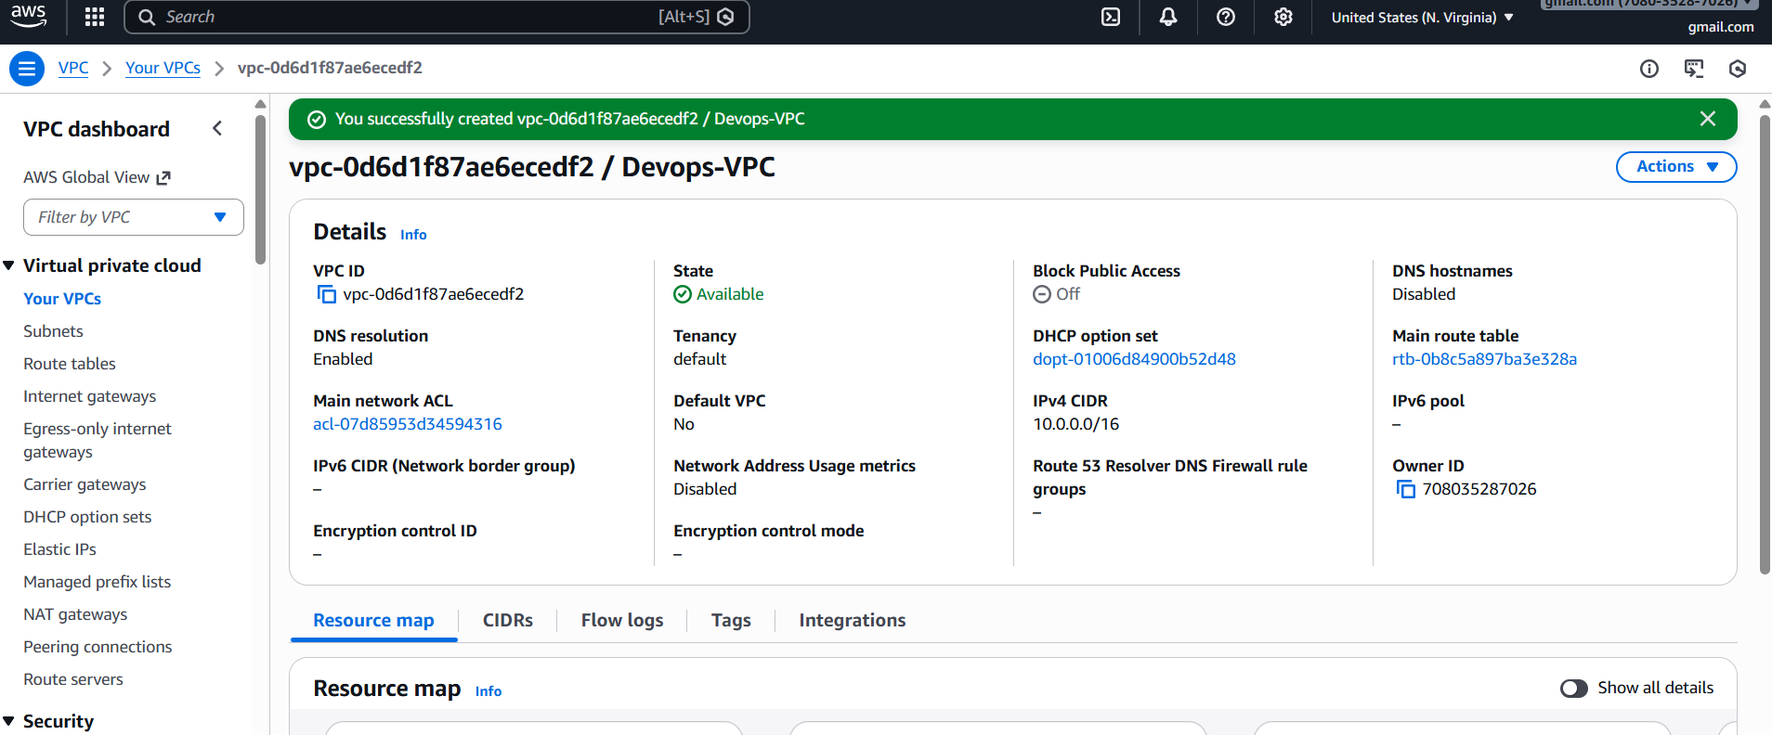

**Now create subnets:**

**Example:**

Public Subnet 1 → 10.0.1.0/24  
Public Subnet 2 → 10.0.2.0/24

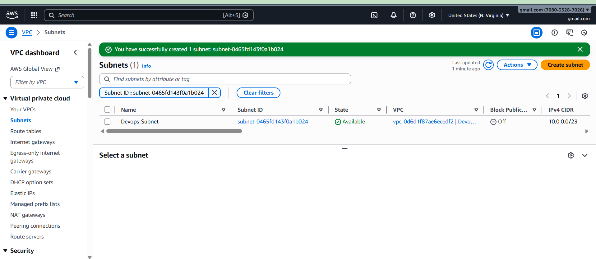

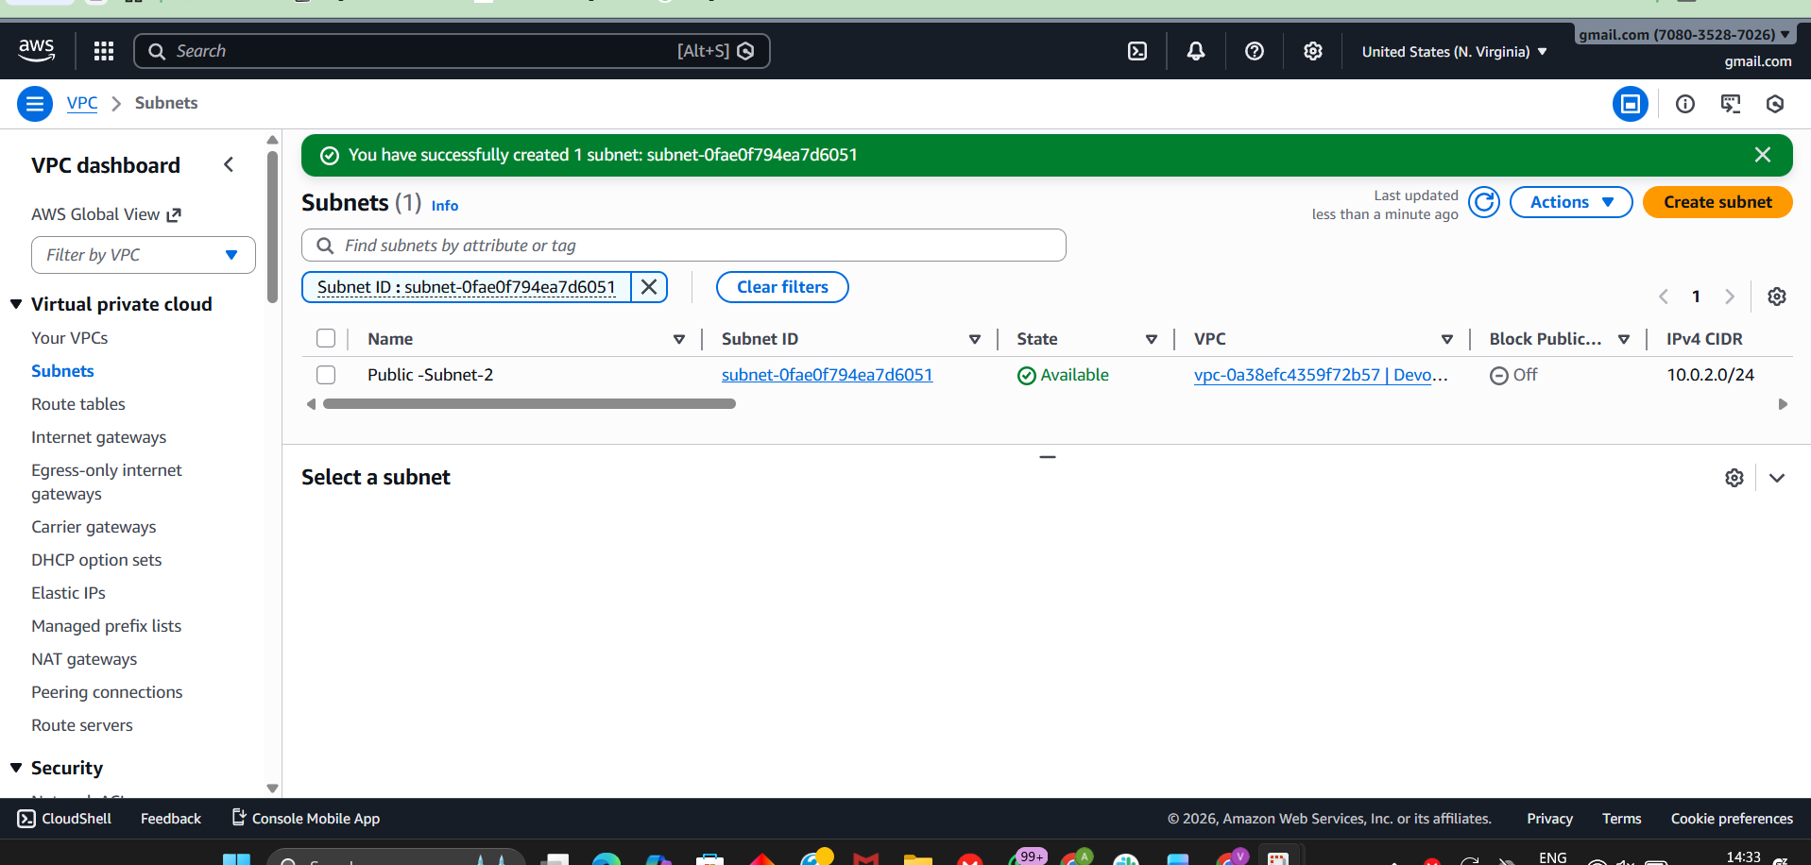

Private Subnet 1 → 10.0.3.0/24  
Private Subnet 2 → 10.0.4.0/24

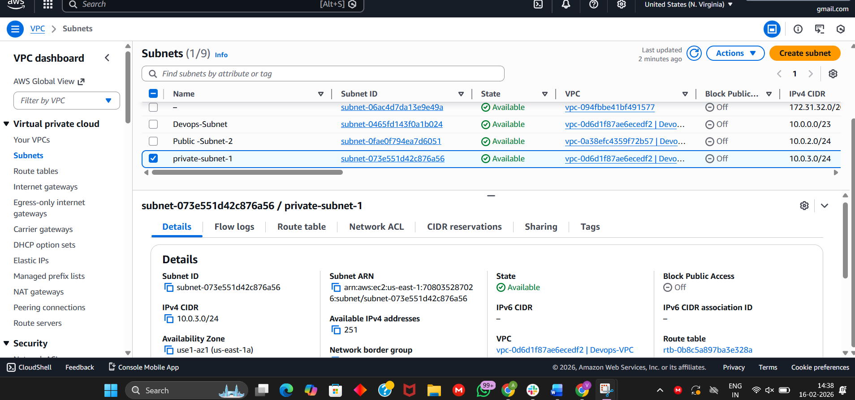

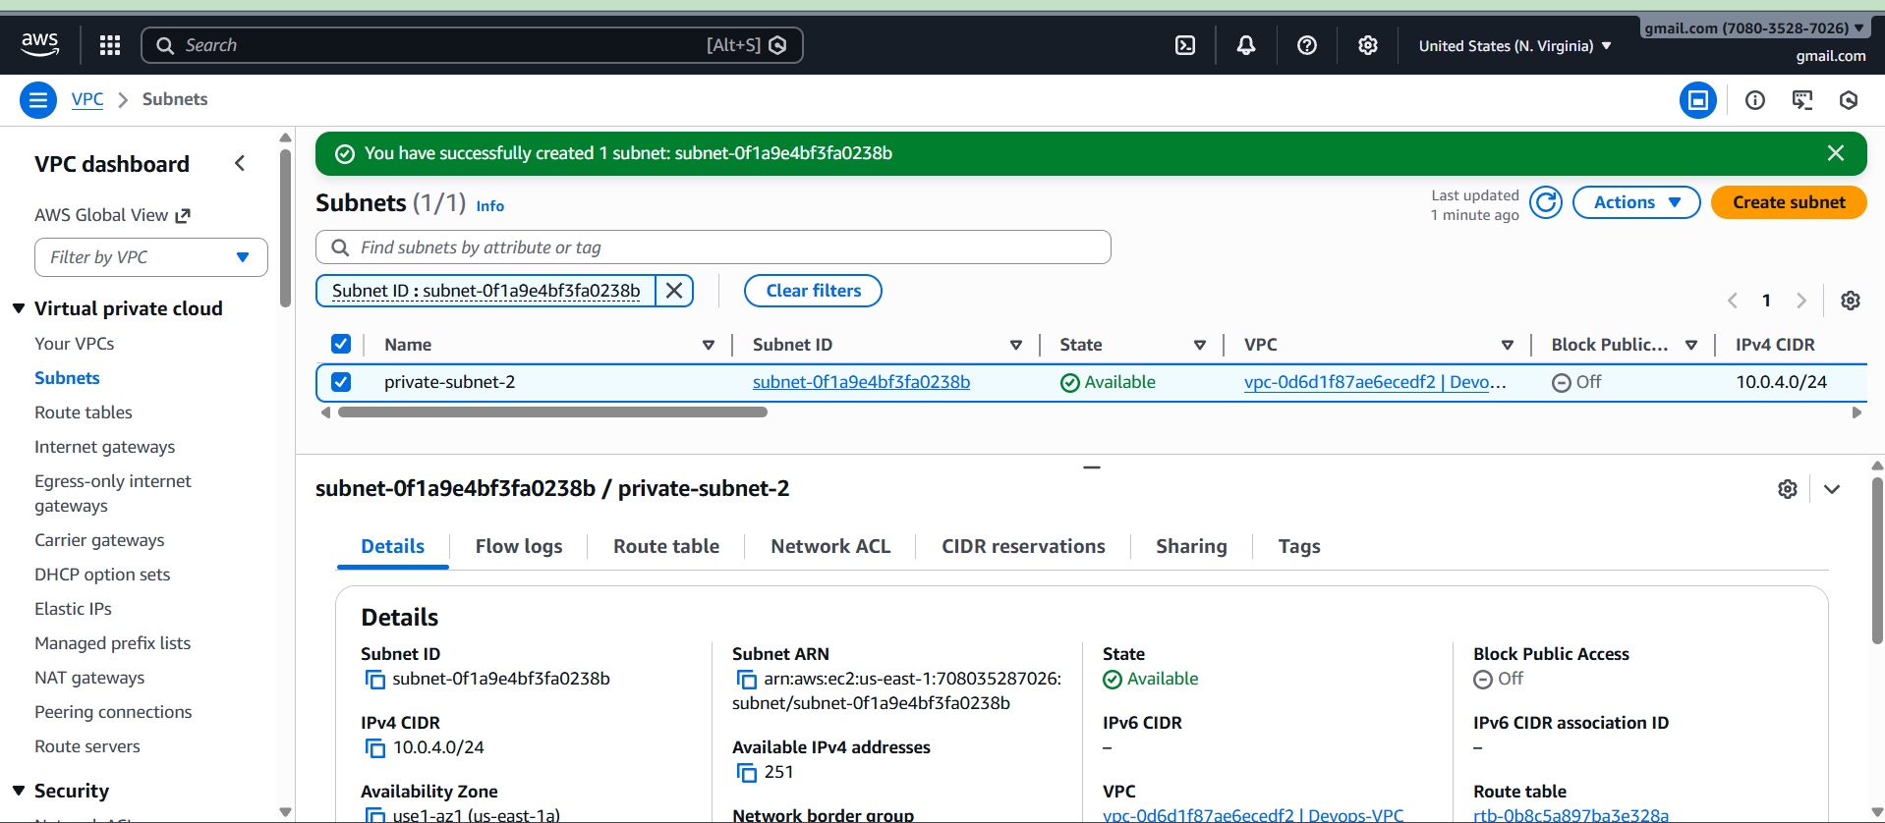

**Step 2: Enable DNS Hostname**

Go to:

VPC → Select your VPC → Actions → Edit VPC settings

Enable:

Enable DNS hostnames  
Enable DNS resolution

Click Save

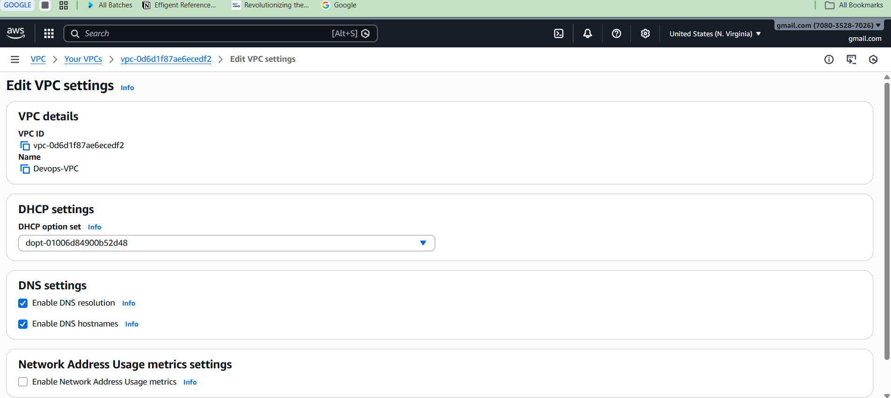

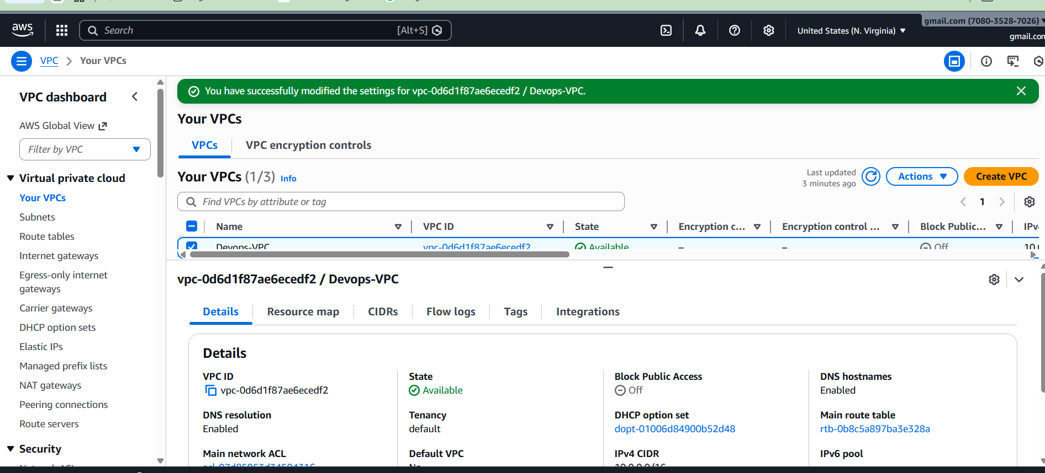

**Step 3: Enable Auto Assign Public IP (Public Subnets only)**

Go to:

Subnets → select Public Subnet → Edit

Enable:

Auto-assign public IPv4 address

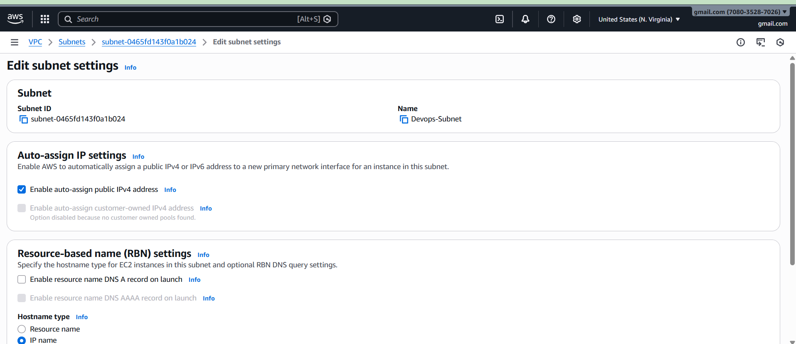

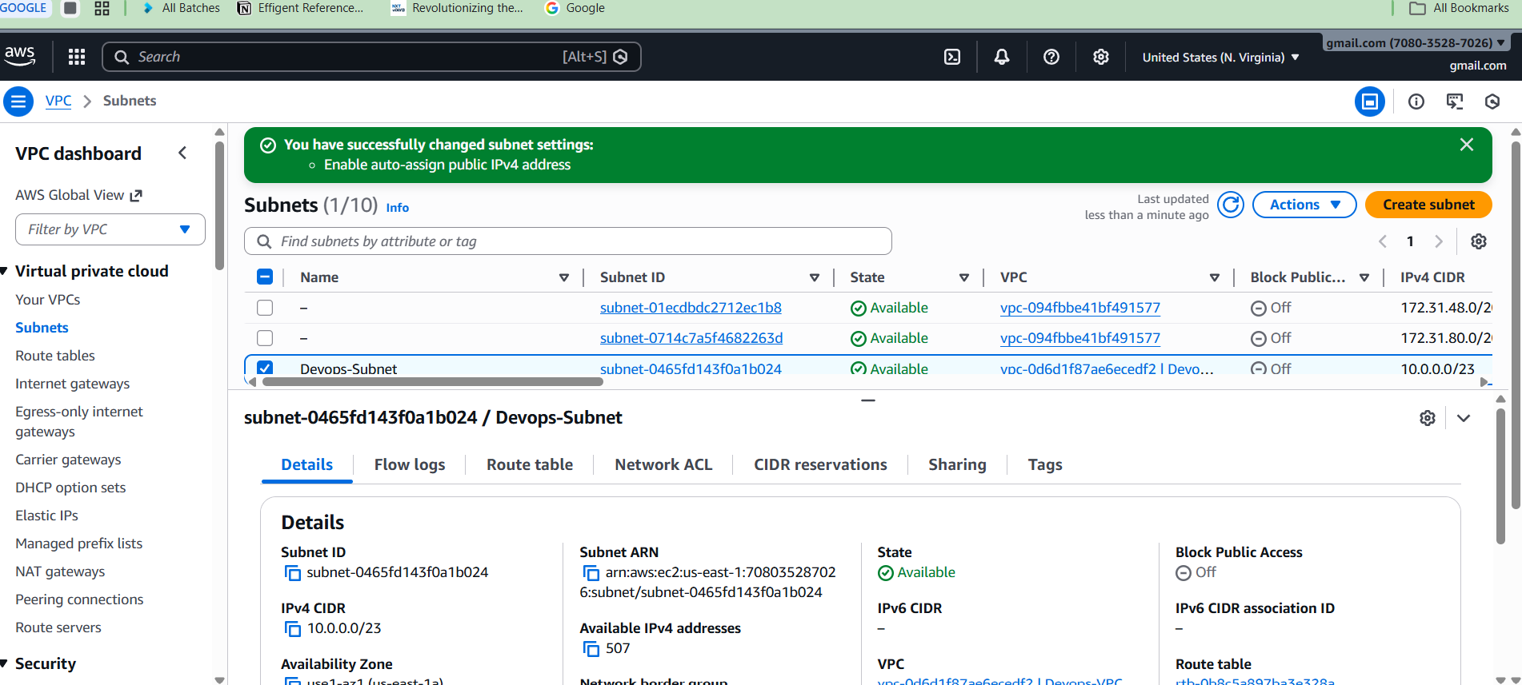

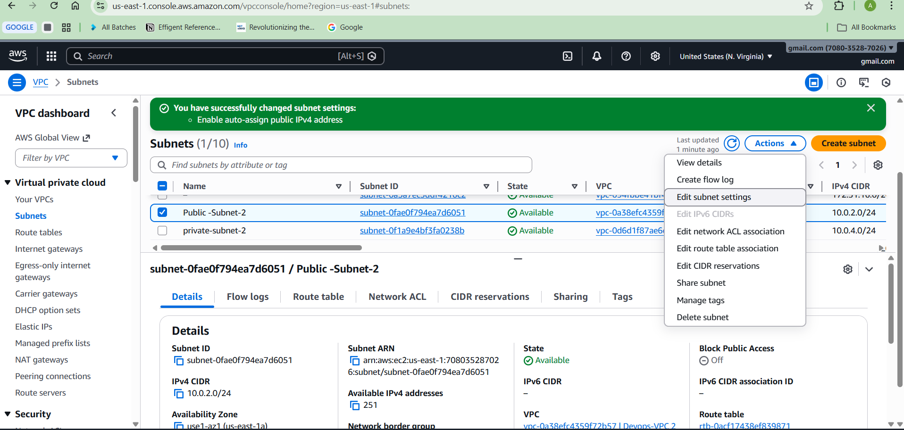

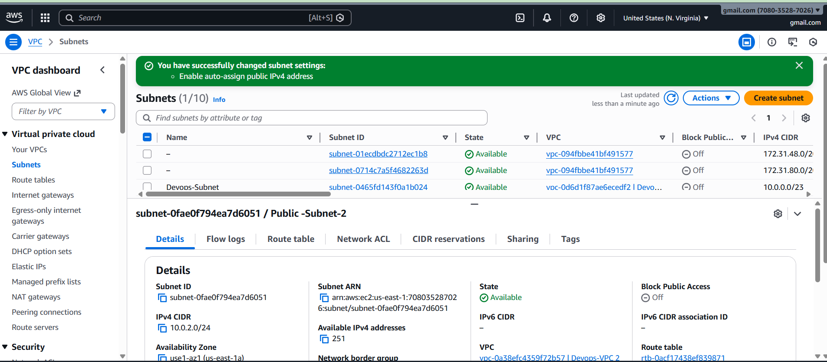

**Step 4: Create Private Route Table**

Go to:

Route Tables → Create route table

Name: Private-RT

Associate:

Private Subnet 1  
Private Subnet 2

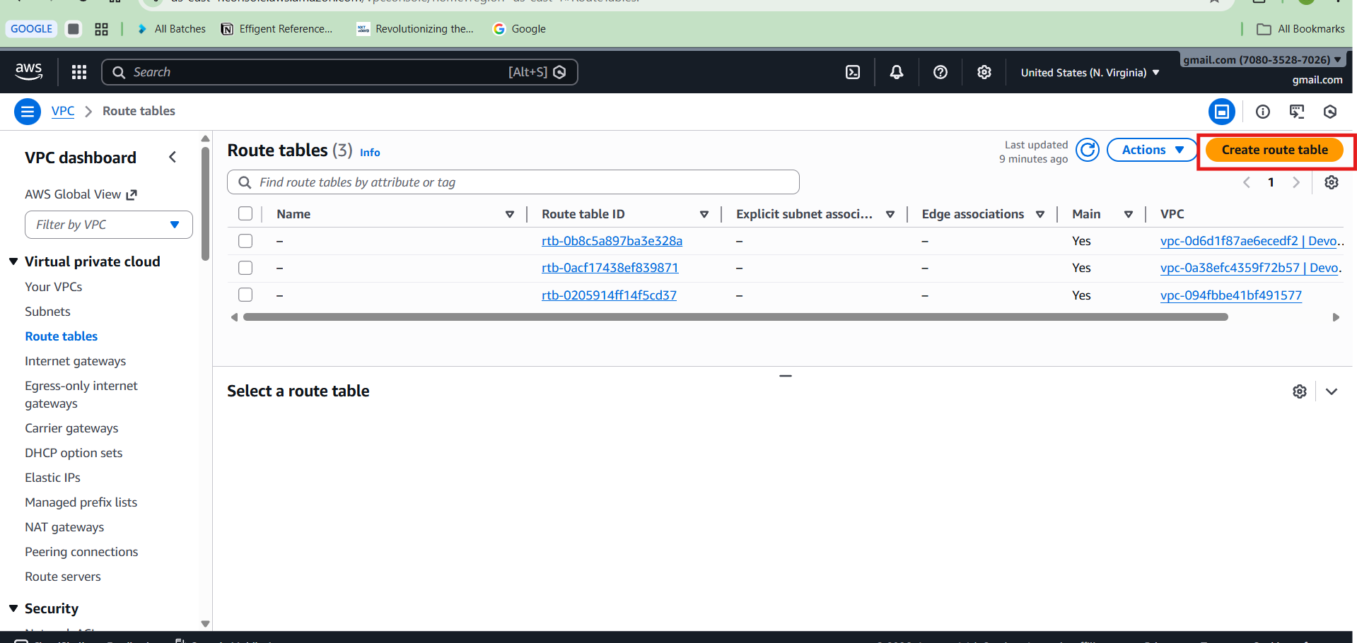

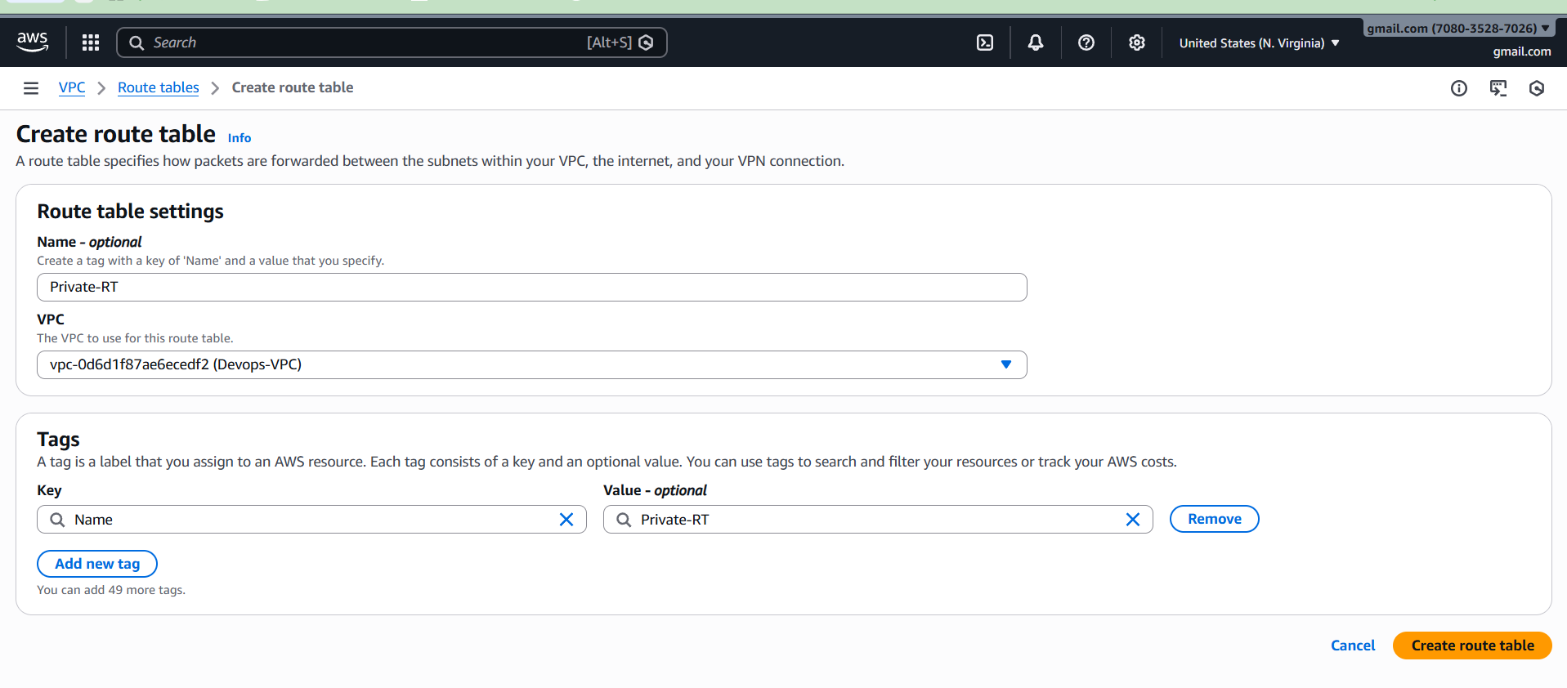

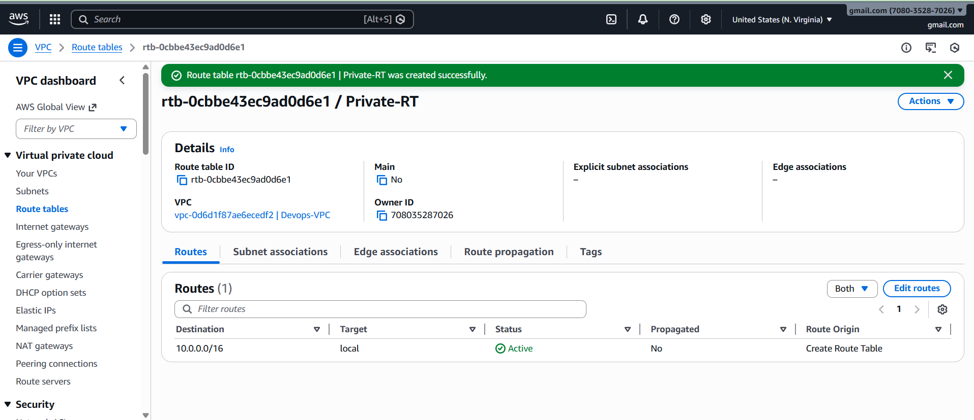

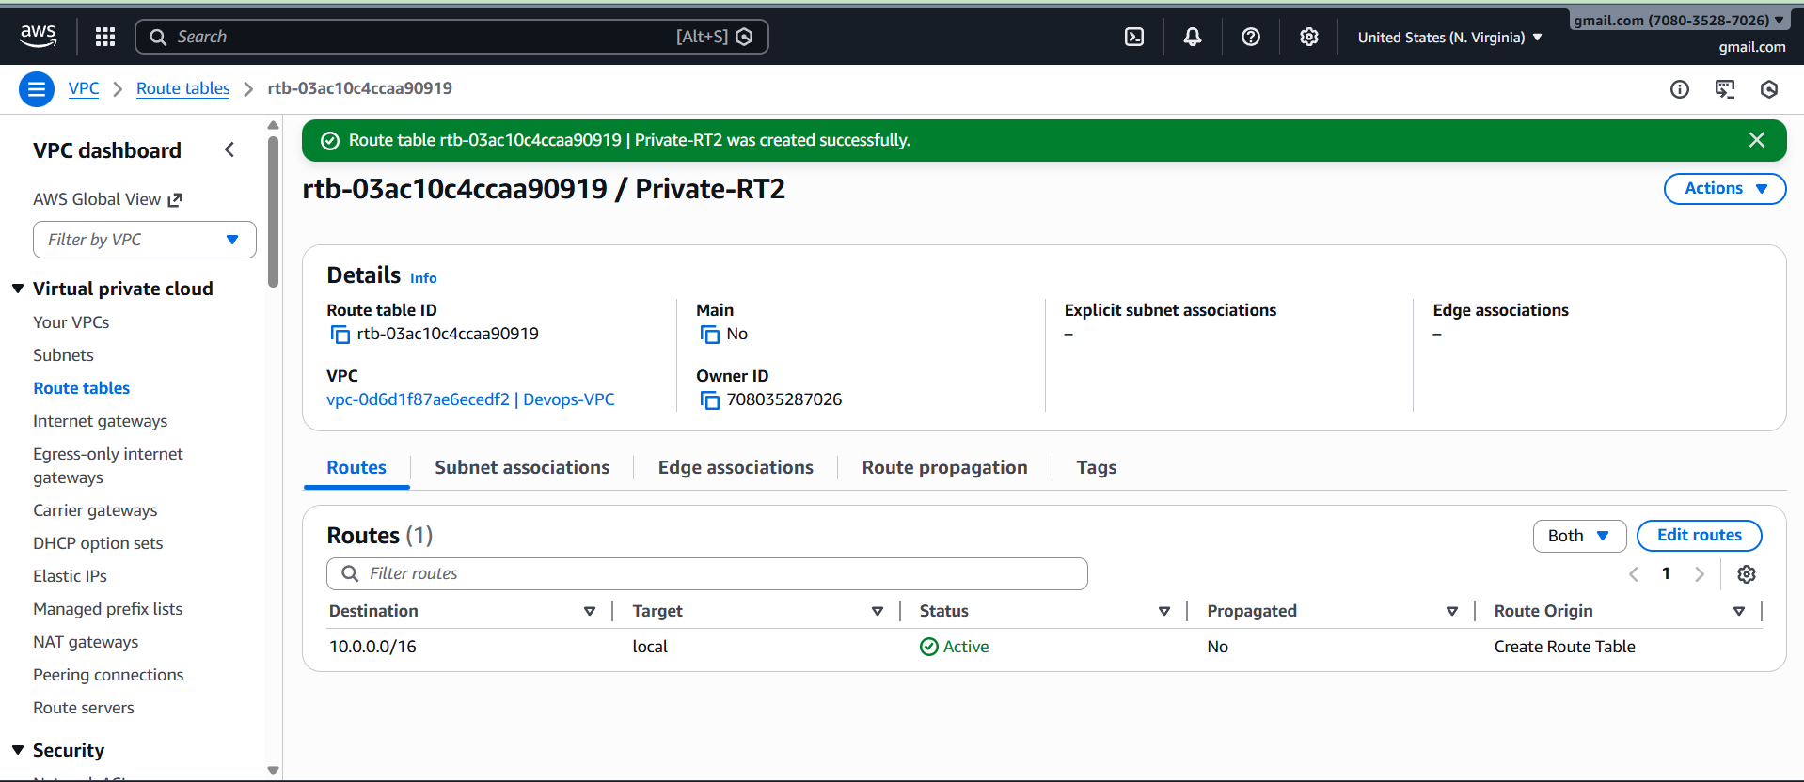

**Step 5: Create Public Route Table**

Create:

Name: Public-RT

Associate:

Public Subnet 1  
Public Subnet 2

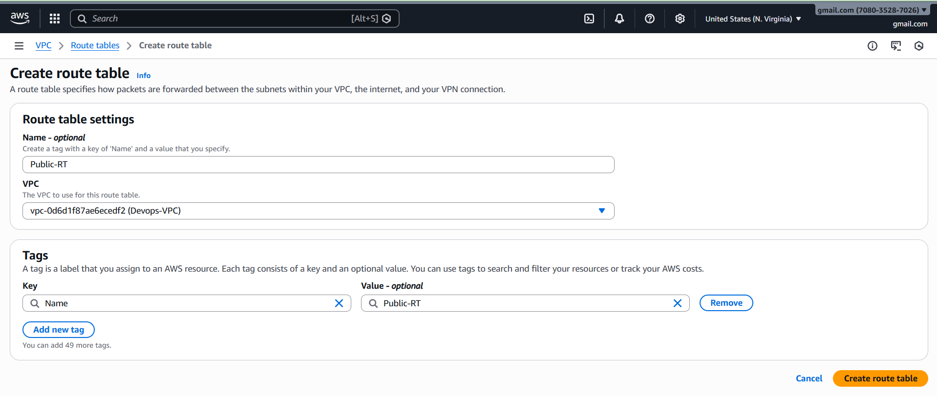

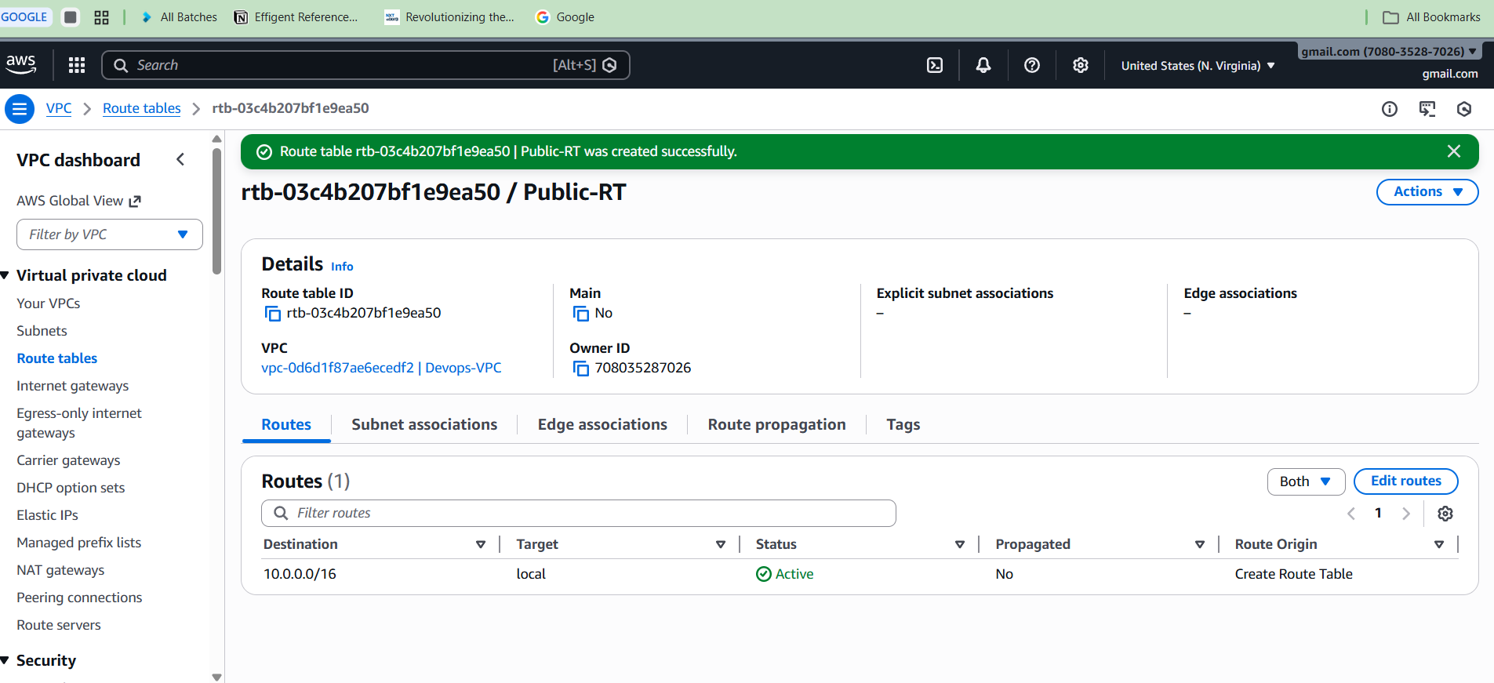

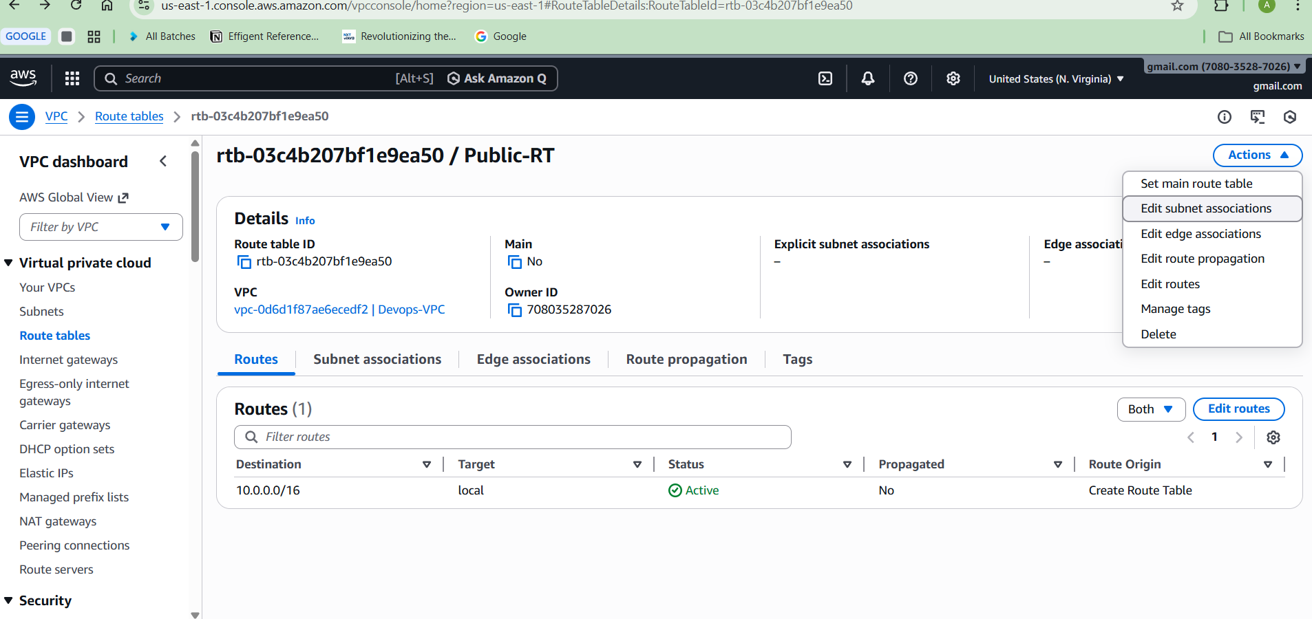

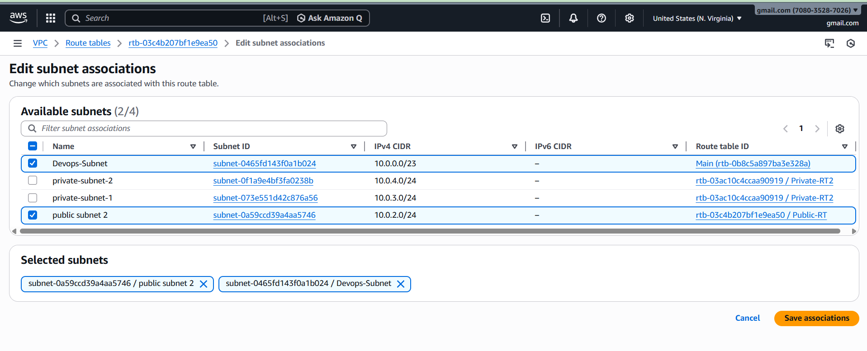

**Step 6: Create Internet Gateway**

Go to:

Internet Gateway → Create

Name: DevOps-IGW

Attach to VPC

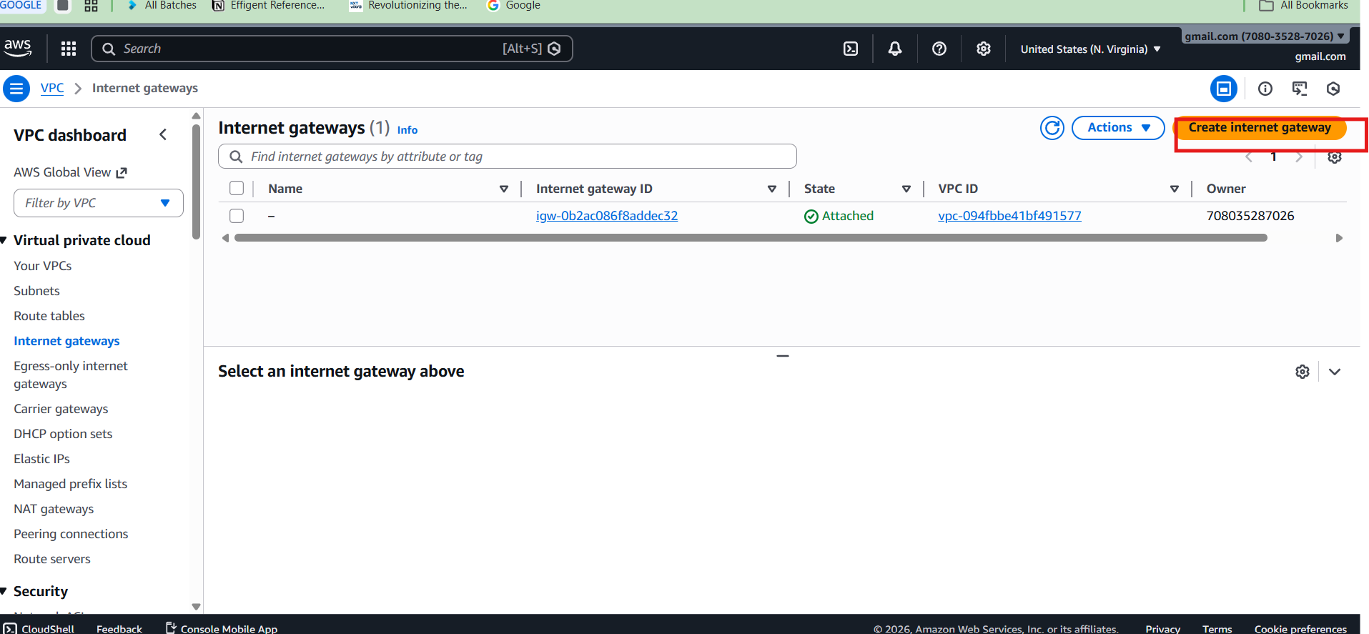\

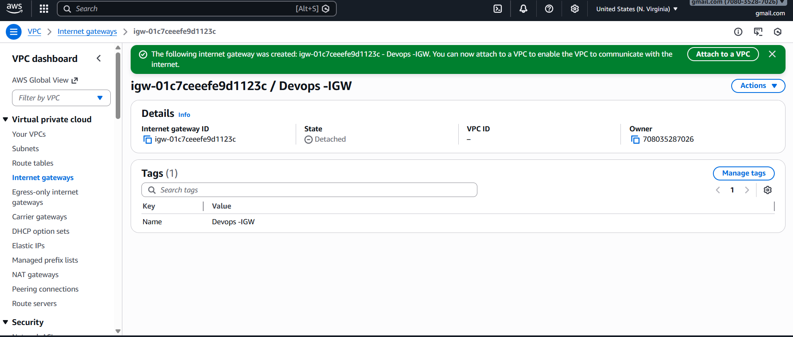

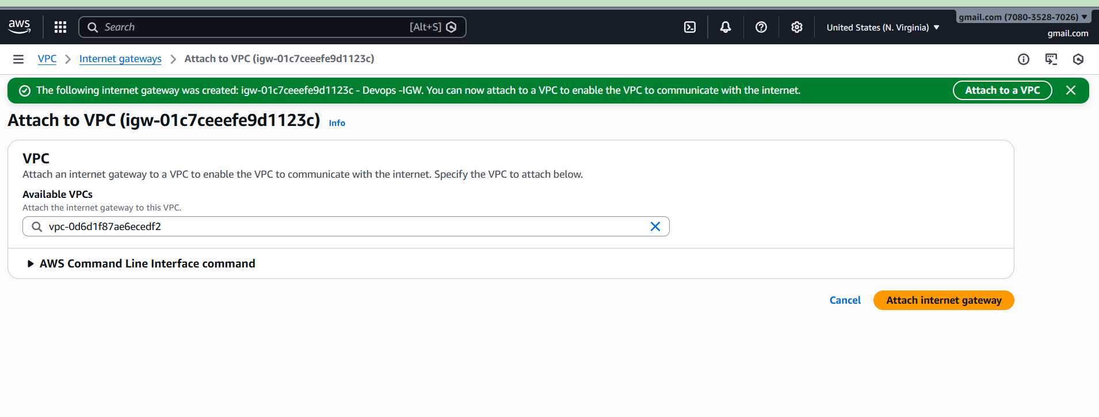

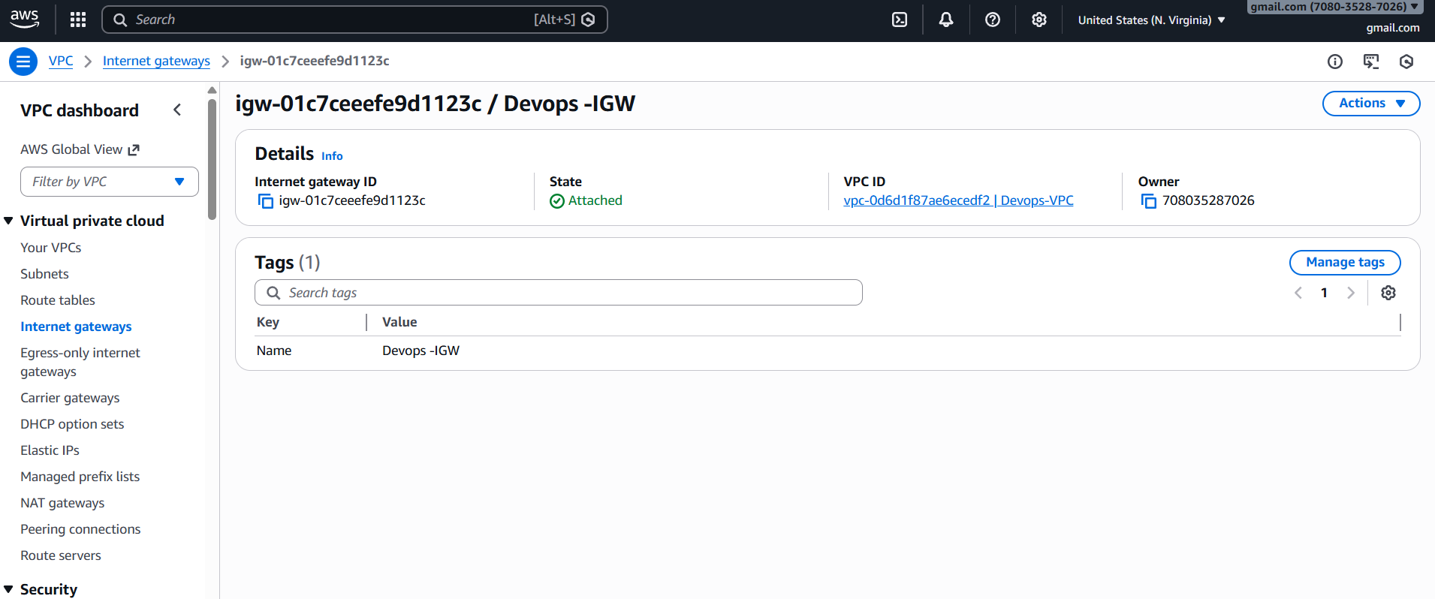

**Add route in Public Route Table:**

**Destination:**

0.0.0.0/0

**Target:**

Internet Gateway

This gives internet access to public subnets.

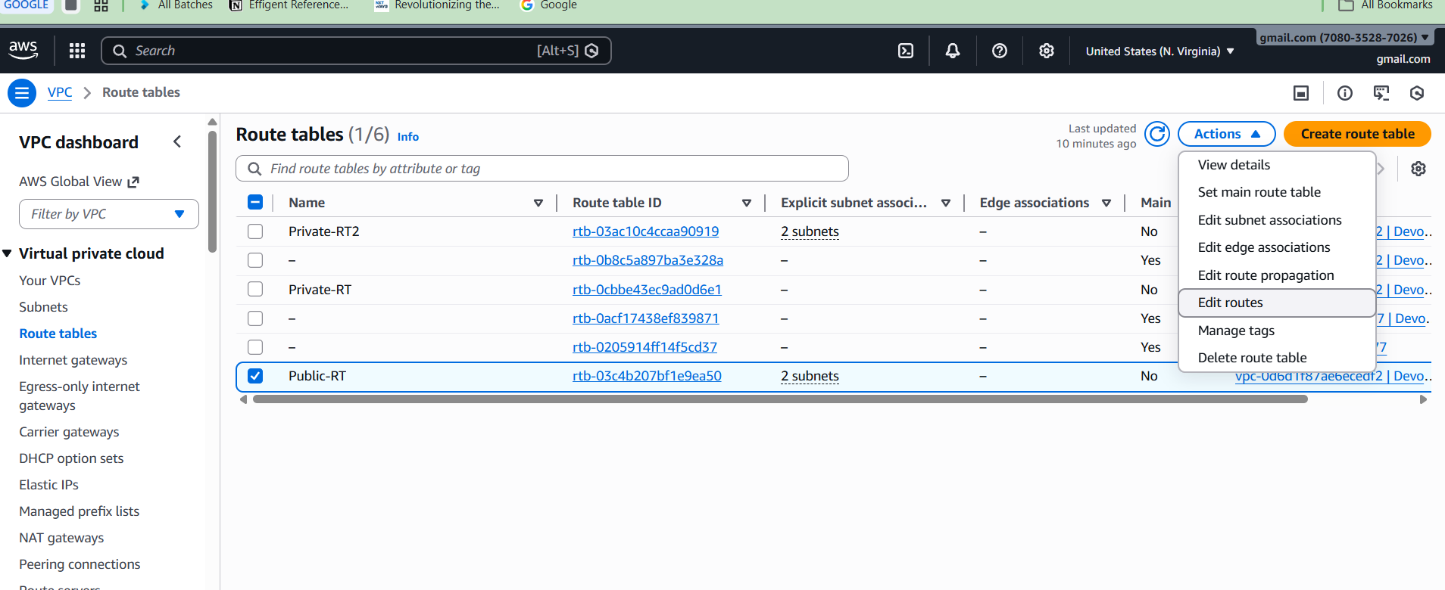

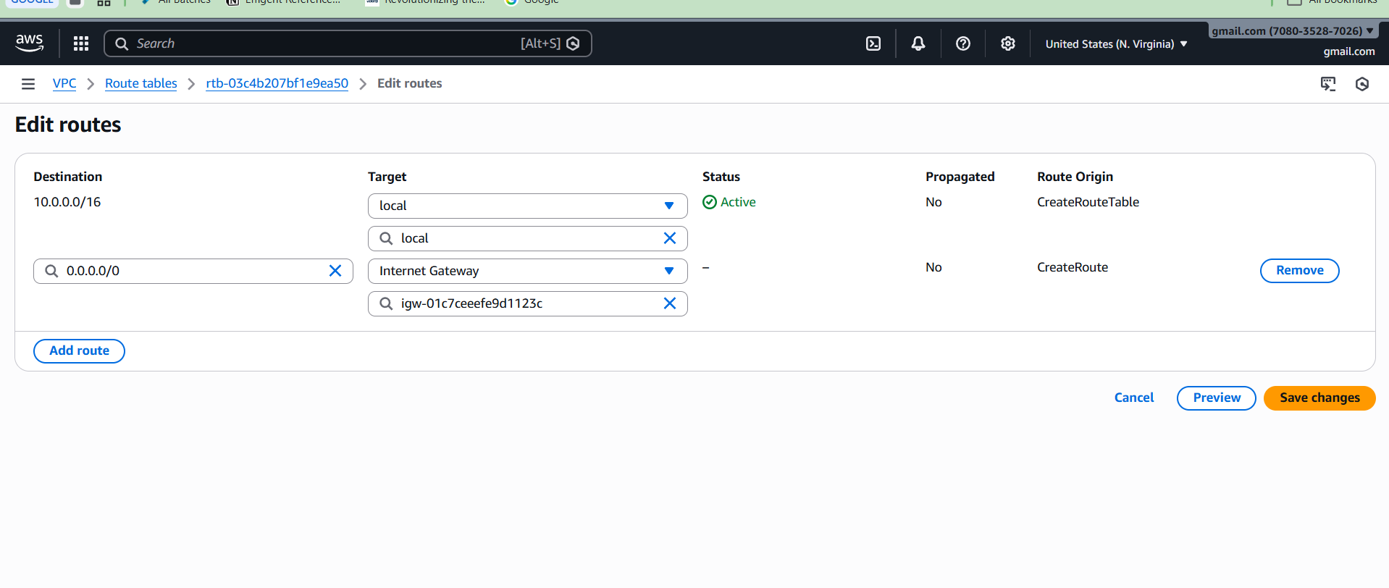

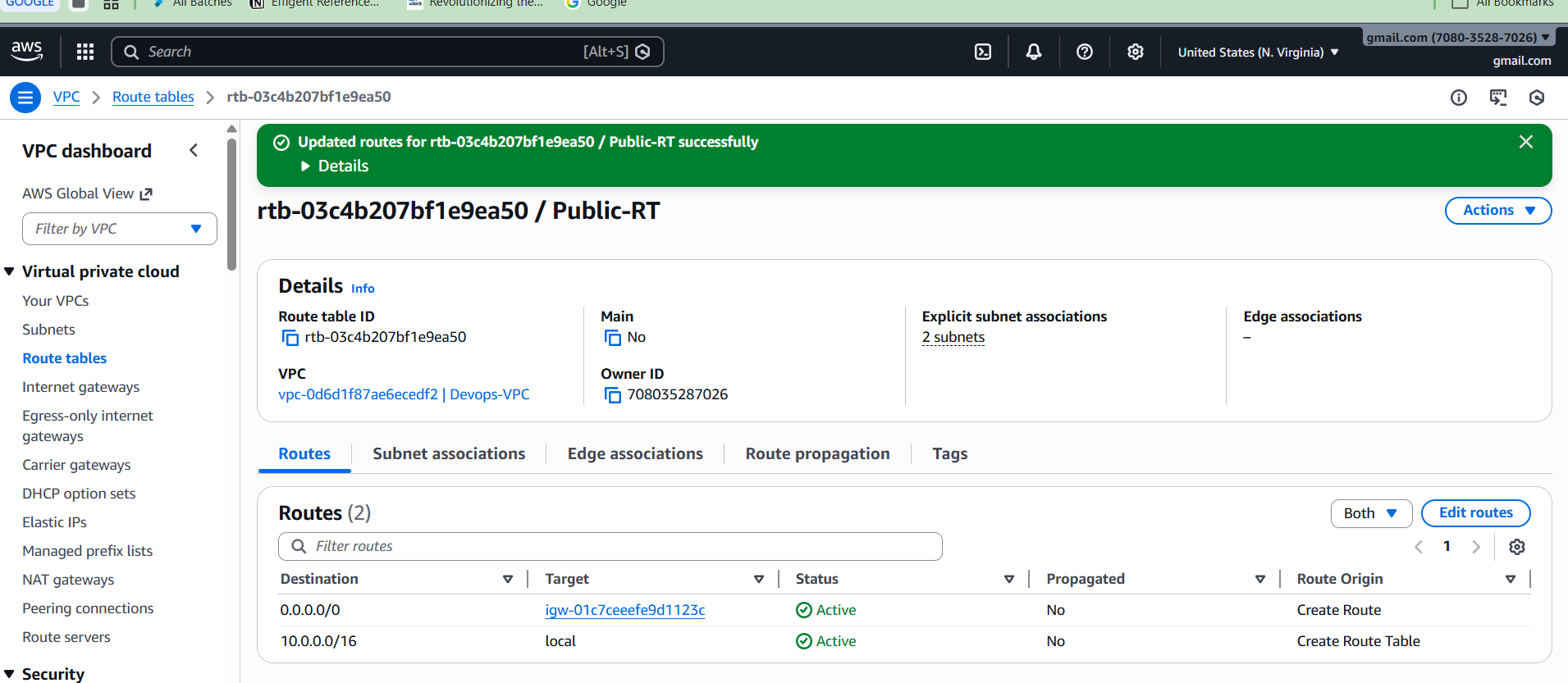

**Step 7) Create EC2 Instances**

Create 2 EC2:

**Public EC2**

Subnet: Public subnet  
Auto assign public IP: Enabled  
Instance type: t2.micro

Install PHP:

Connect and run:

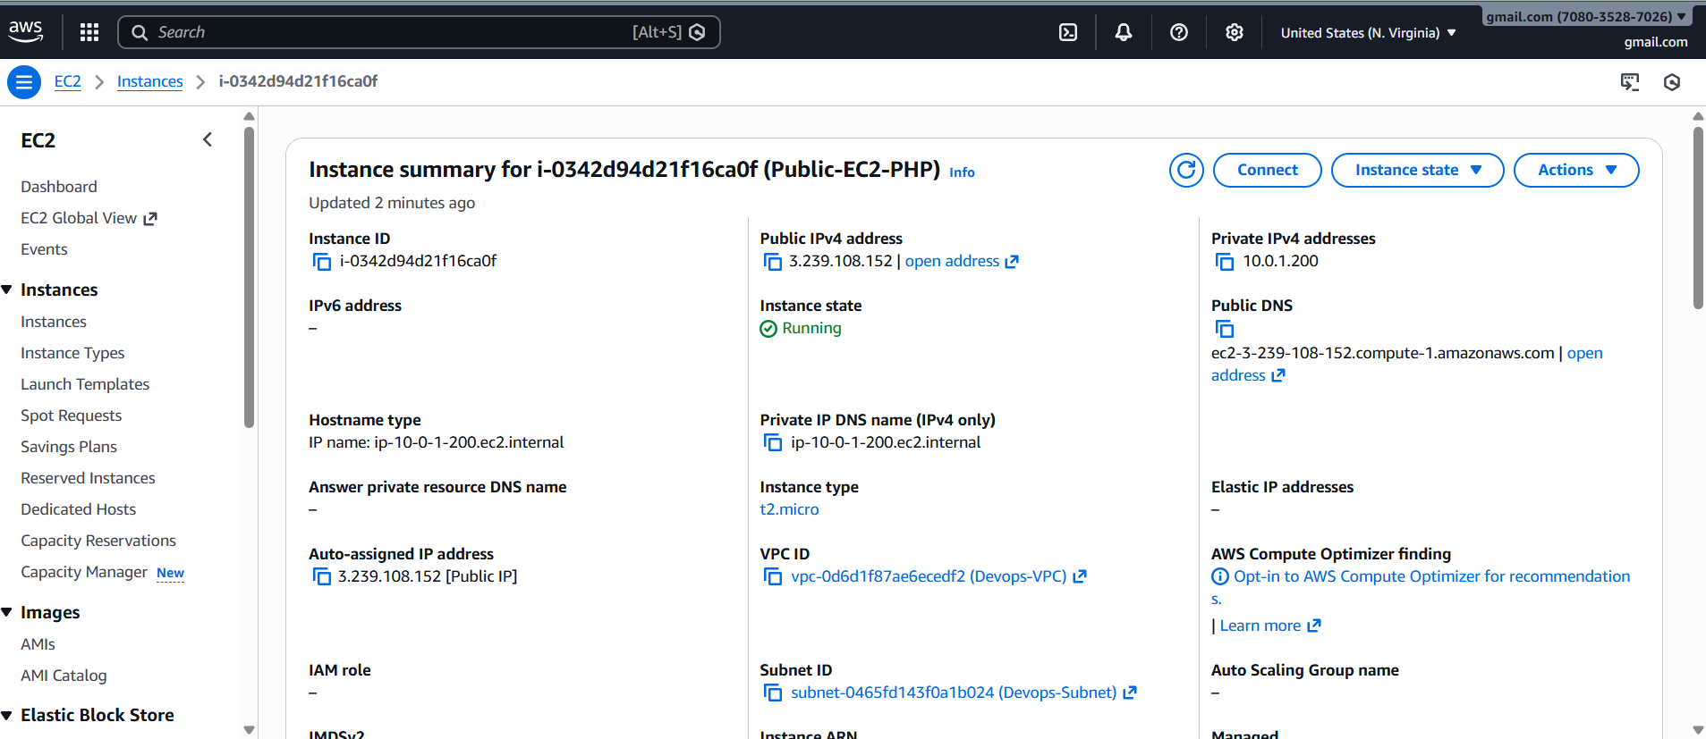

***sudo yum update -y***

***sudo yum install httpd php -y***

***sudo systemctl start httpd***

***sudo systemctl enable httpd***

***sudo nano /var/www/html/info.php***

***In Editor***

***<?php***

***phpinfo()***

***?>***

***SAVE***

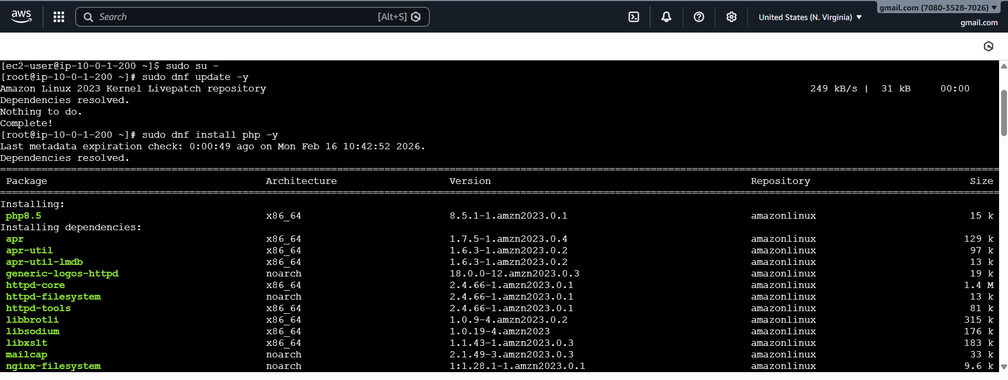

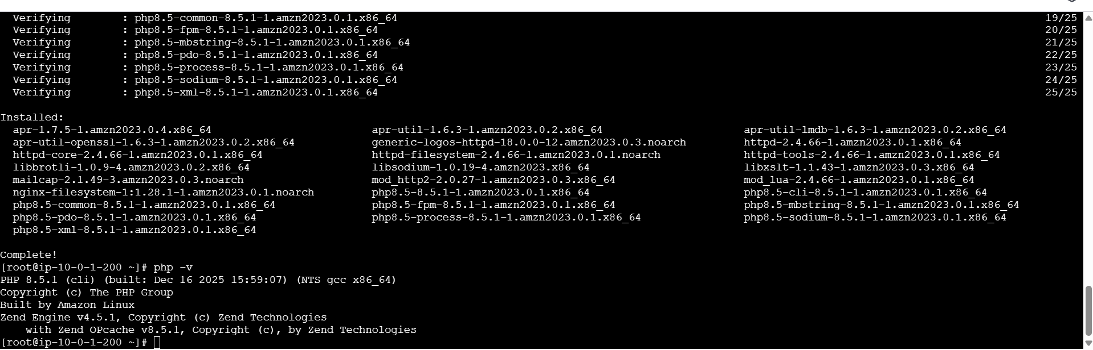

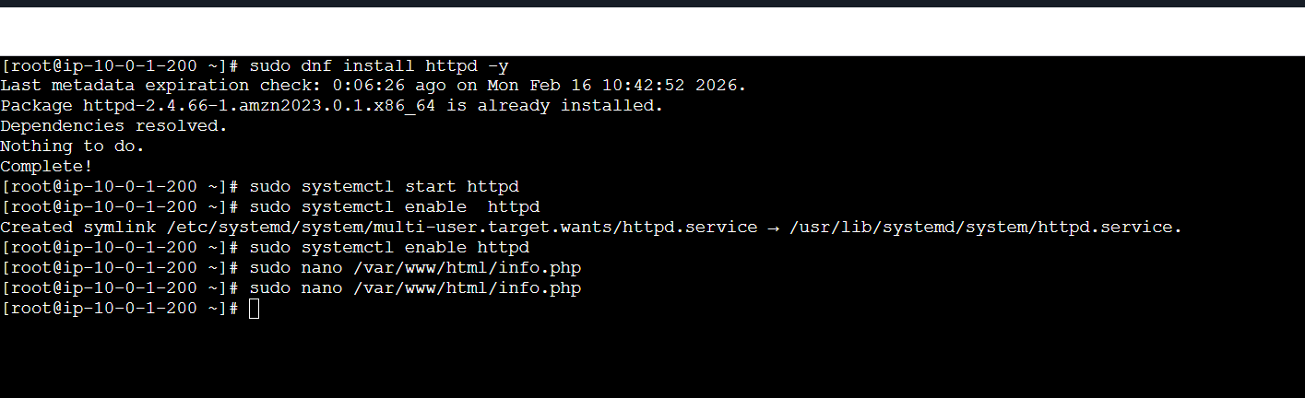

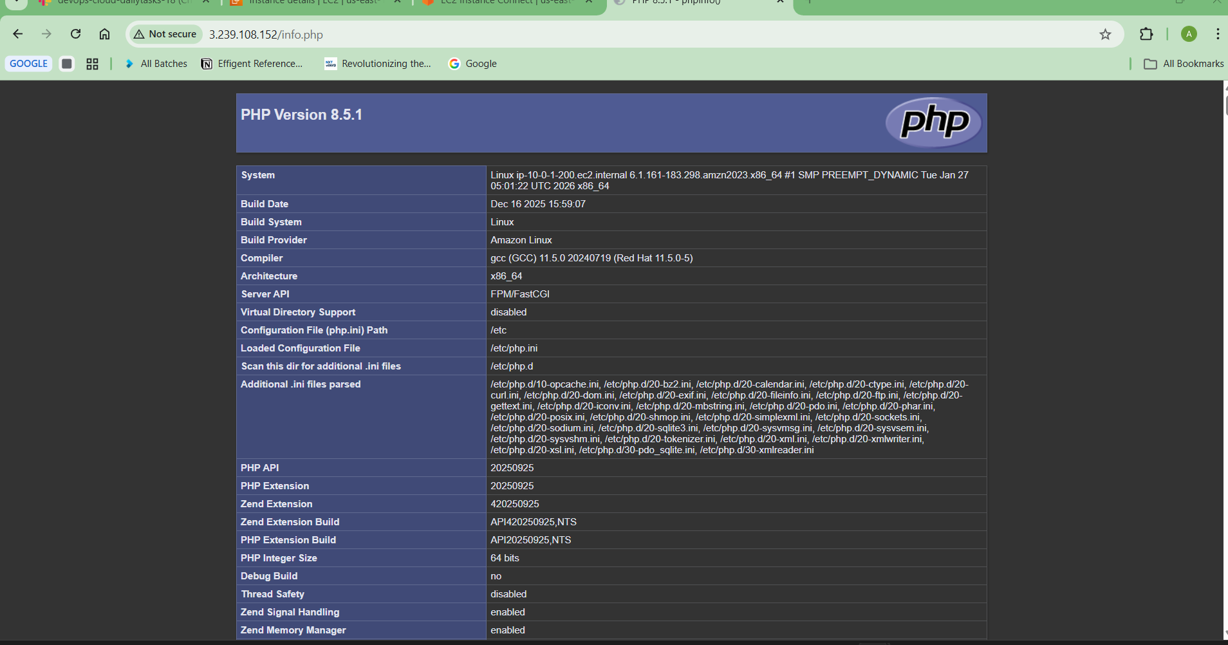

**Step 7: Create NAT Gateway**

Go to:

NAT Gateway → Create

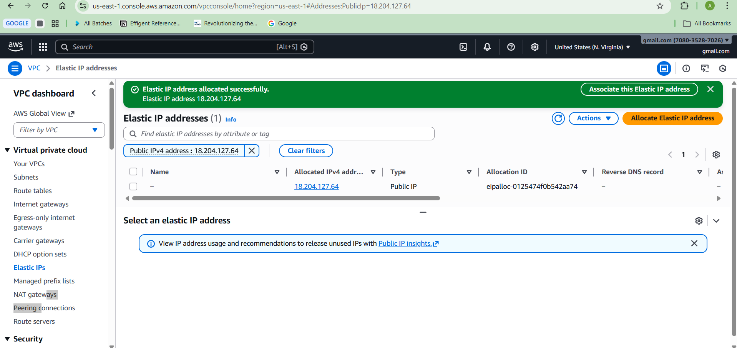

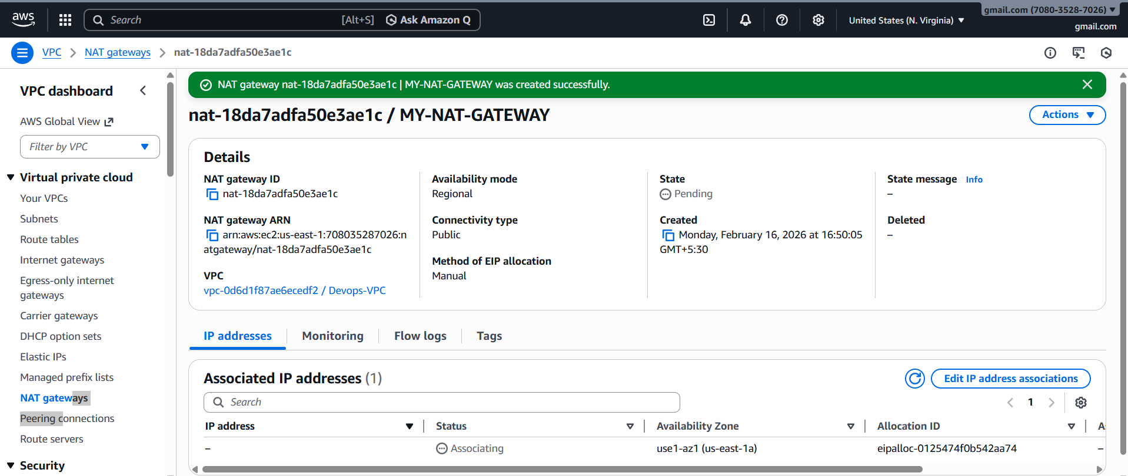

**Select:**

Subnet: Public Subnet  
Elastic IP: Allocate new

**Click Create**

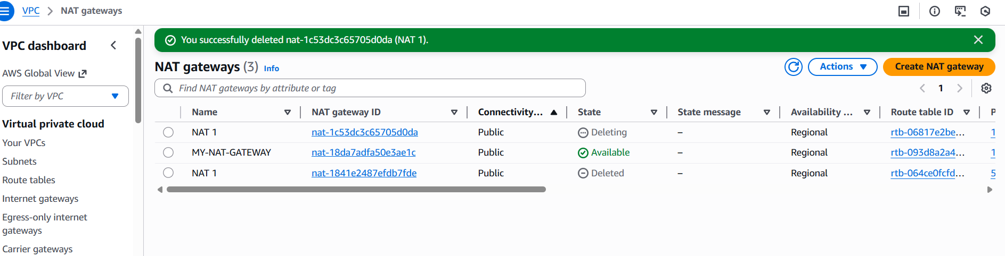

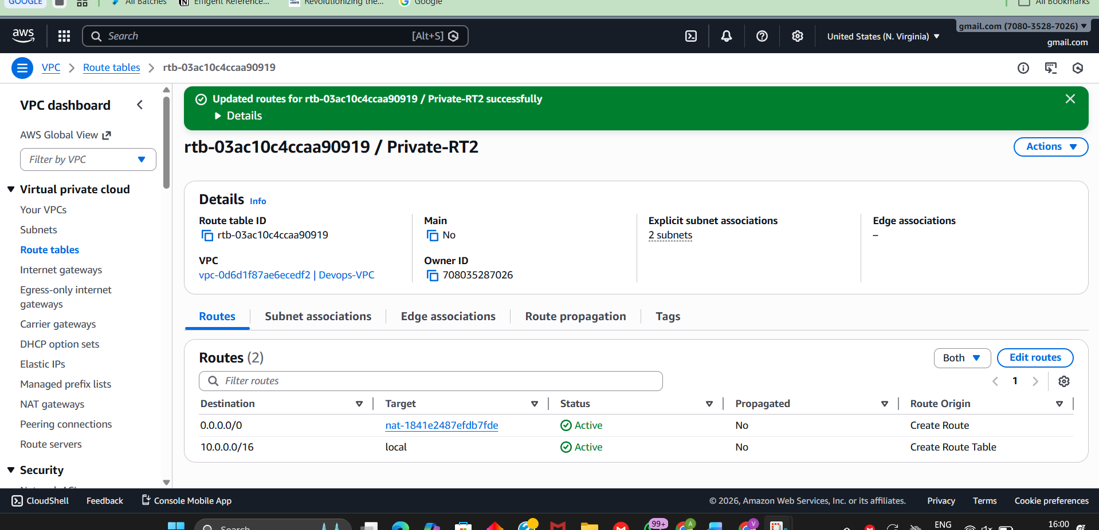

**Now go to Private Route Table → Add route:**

**Destination:**

0.0.0.0/0

**Target:**

NAT Gateway

Now private EC2 can access internet.

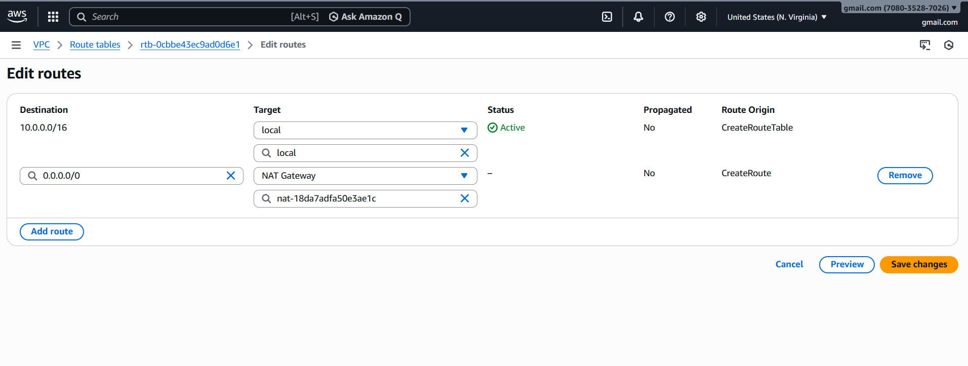

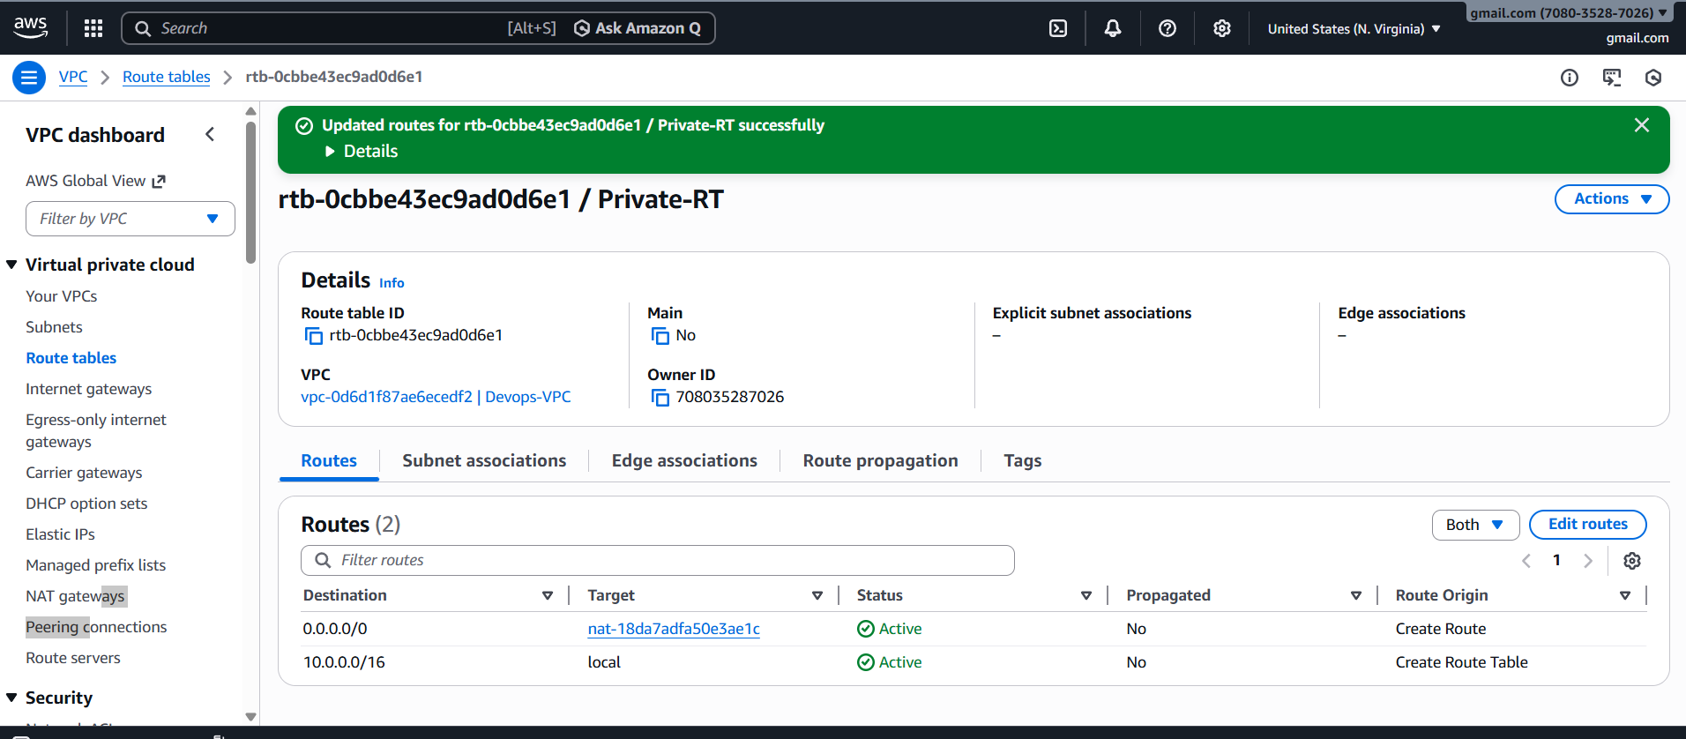

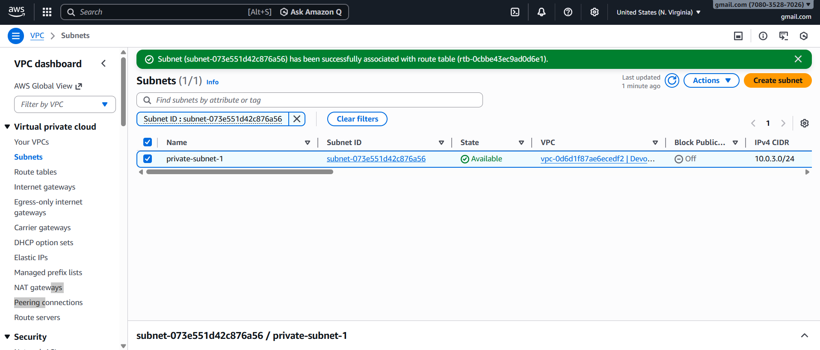

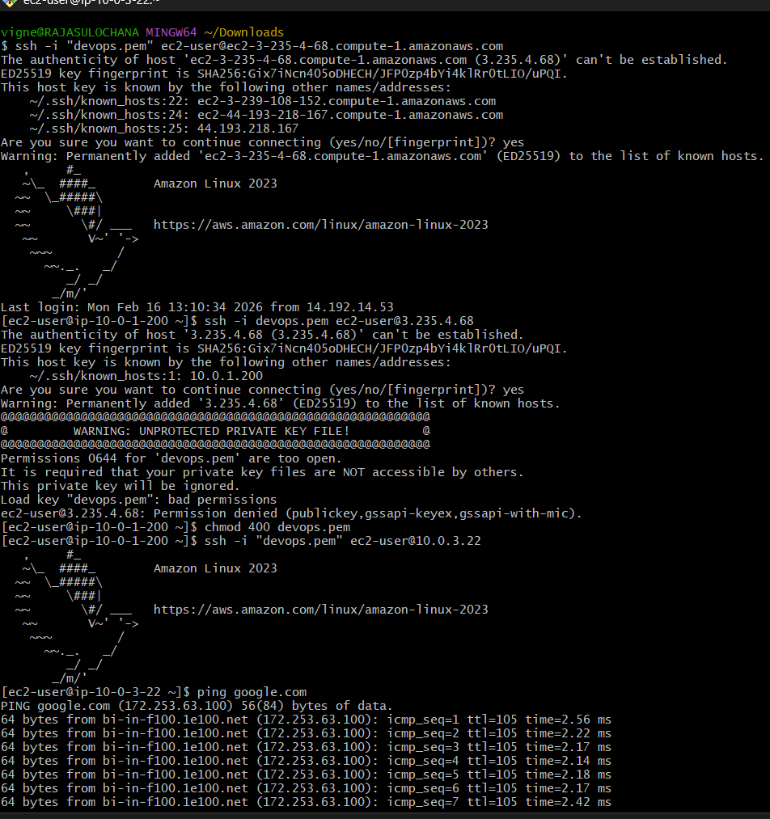

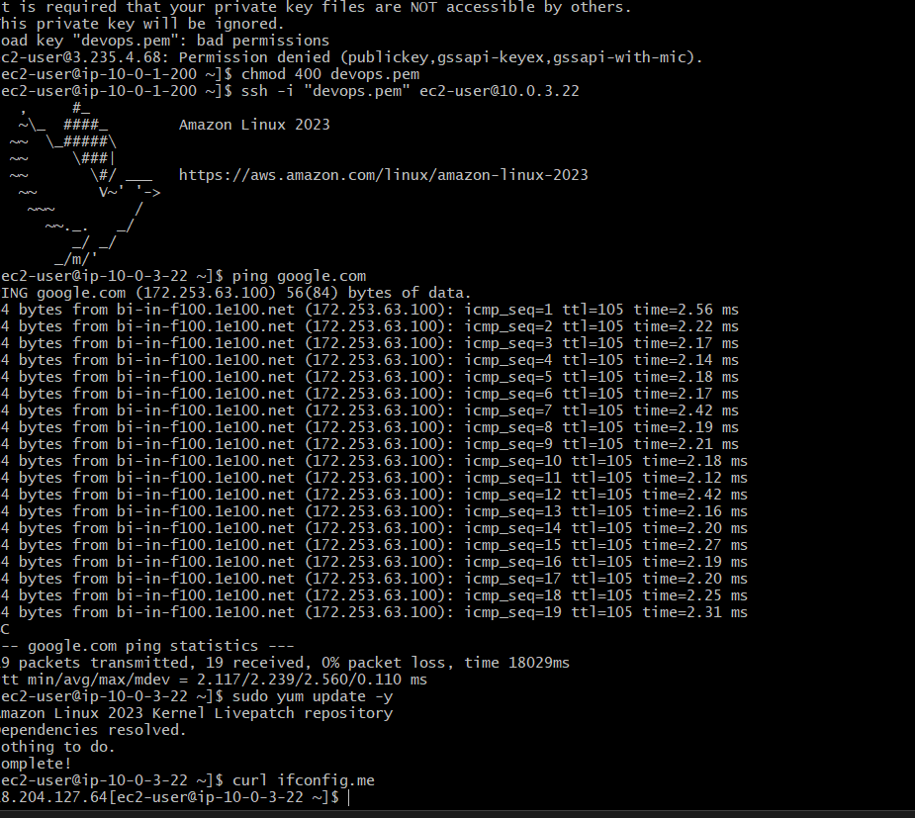

**Step 9: Install Apache Tomcat in Private EC2 and deploy sample app**

Login to Private EC2

ssh -i devops.pem ec2-user@PRIVATE-IP

sudo yum install java-11-amazon-corretto -y

sudo yum install java-11-amazon-corretto -y

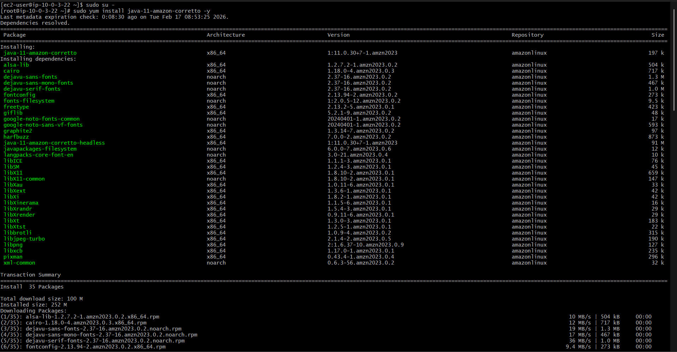

java -version

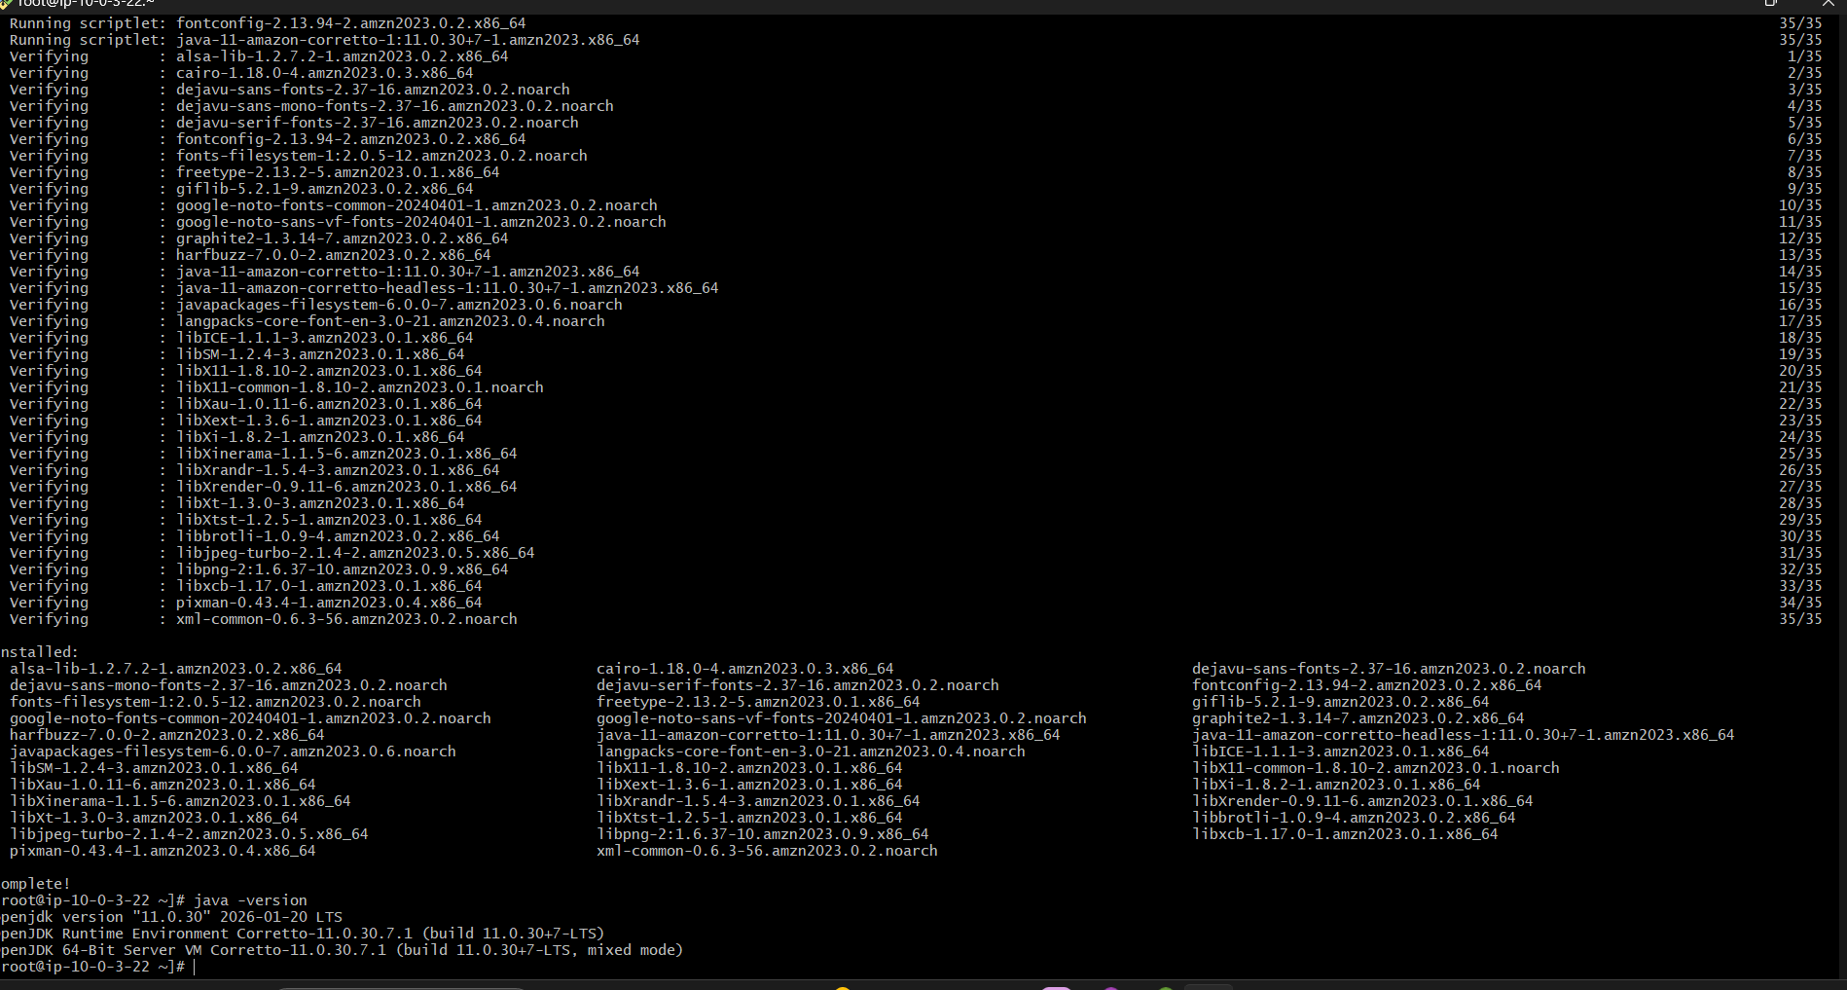

cd /opt

sudo wget <https://archive.apache.org/dist/tomcat/tomcat-9/v9.0.89/bin/apache-tomcat-9.0.89.tar.gz>

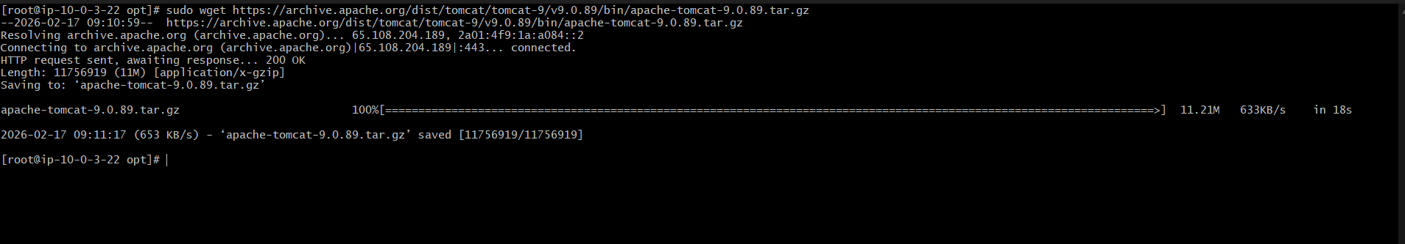

sudo tar -xvzf apache-tomcat-9.0.89.tar.gz

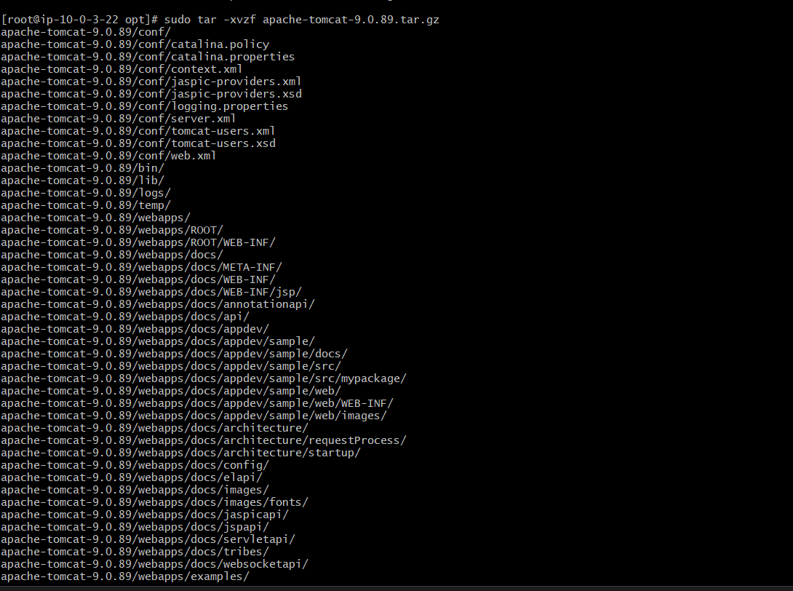

sudo mv apache-tomcat-9.0.89 tomcat

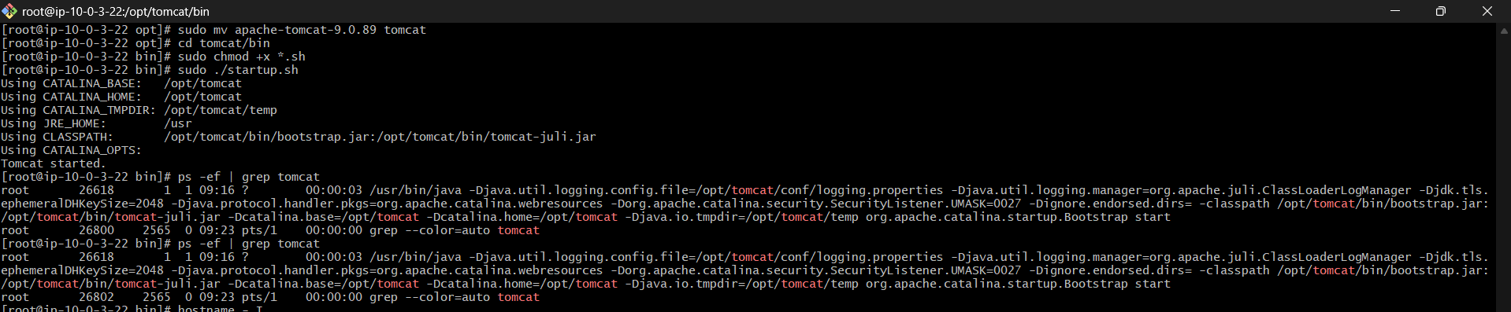

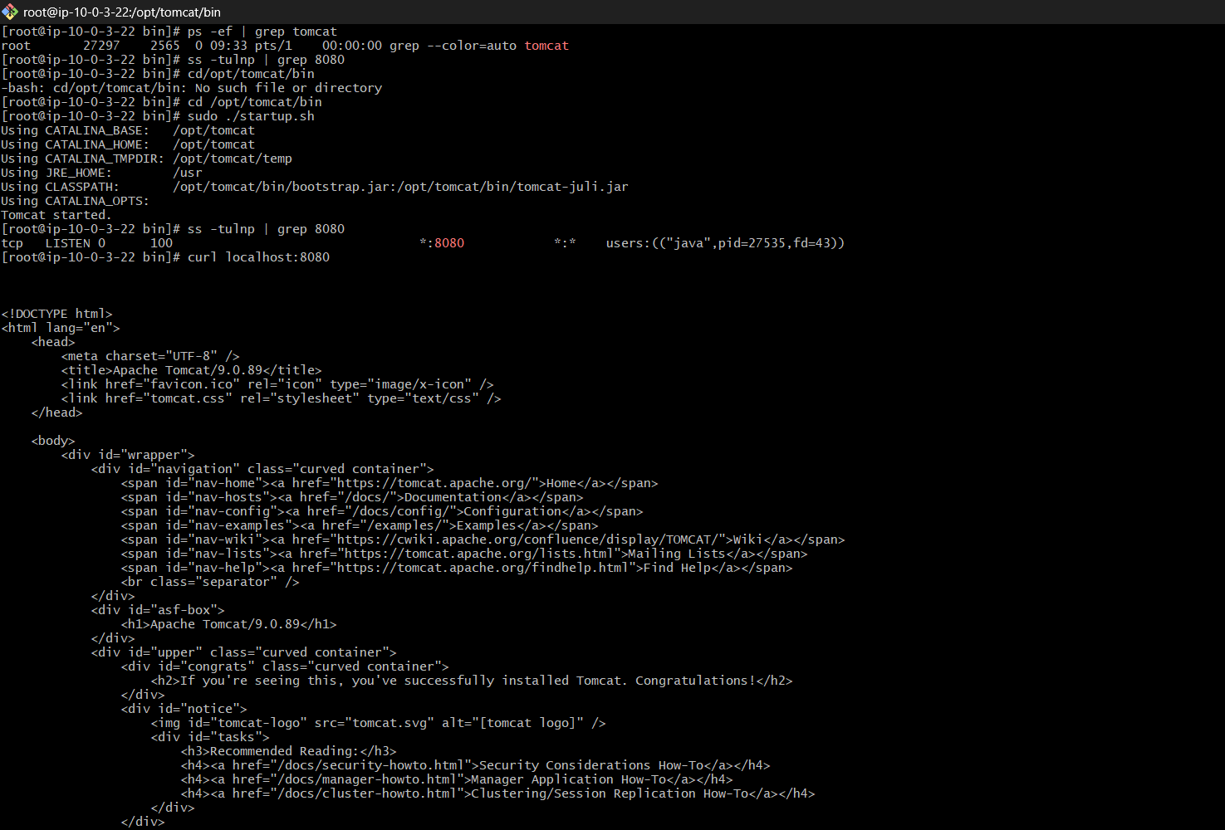

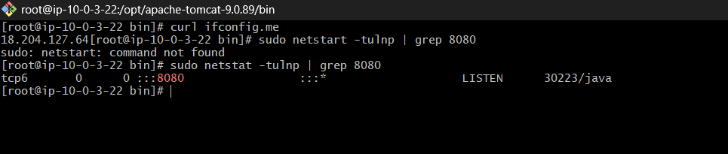

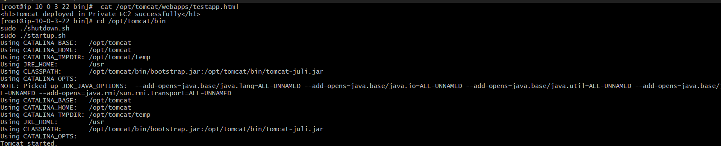

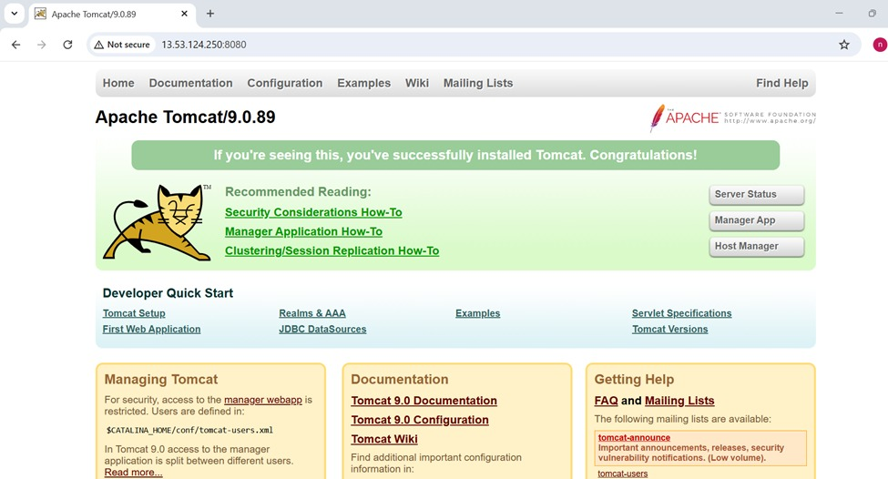

**Deploy Sample Application**

Commands:

cd /opt/tomcat/webapps

sudo mkdir sample

cd sample

sudo nano index.jsp

**Paste the following content:**

<html>  
<body>  
<h1>Welcome to Tomcat Private EC2</h1>  
<h2>Deployment Successful</h2>  
</body>  
</html>

**Step 6: Access the Application**

URL: http://PUBLIC-EC2-IP:8080/sample

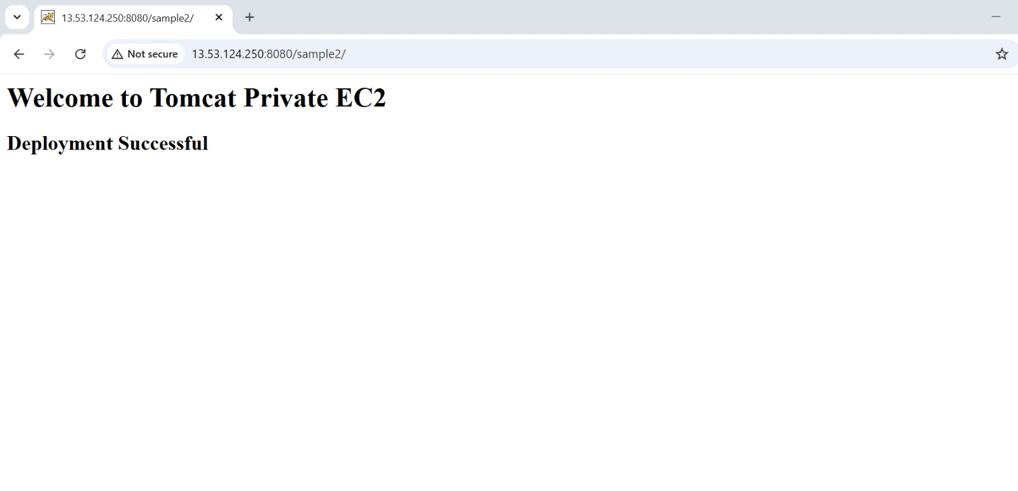

**10: Configure VPC Flow Logs and Store in S3 and CloudWatch**

**Part A: Create S3 bucket**

Go to:

AWS Console → S3 → Create bucket

Enter:

Bucket name:

vpc-flowlogs-bucket-12345

Uncheck:

Block all public access

Click:

Create bucket

Result: S3 bucket created successfully

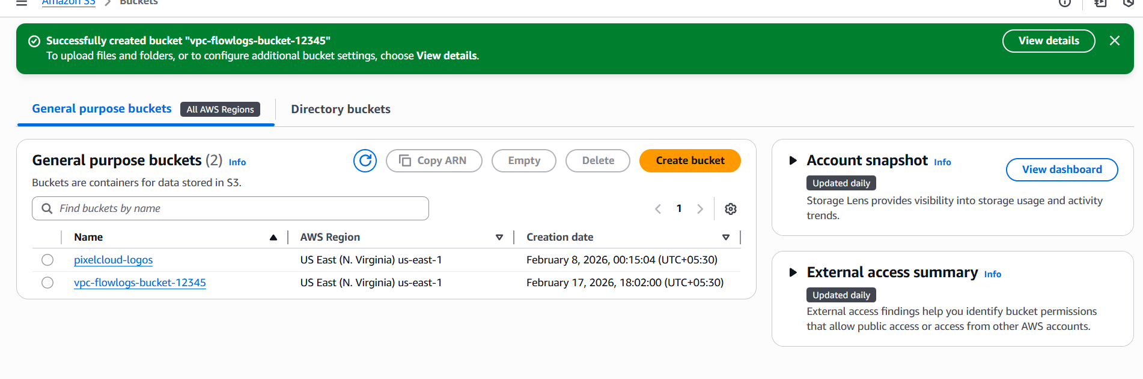

**PART B: Create CloudWatch Log Group**

Step 1: Search for CloudWatch

Step 2: Click Logs → Log groups

Step 3: Click "Create log group"

Step 4: Enter name (example: my-vpc-flowlogs-group)

Step 5: Click "Create"

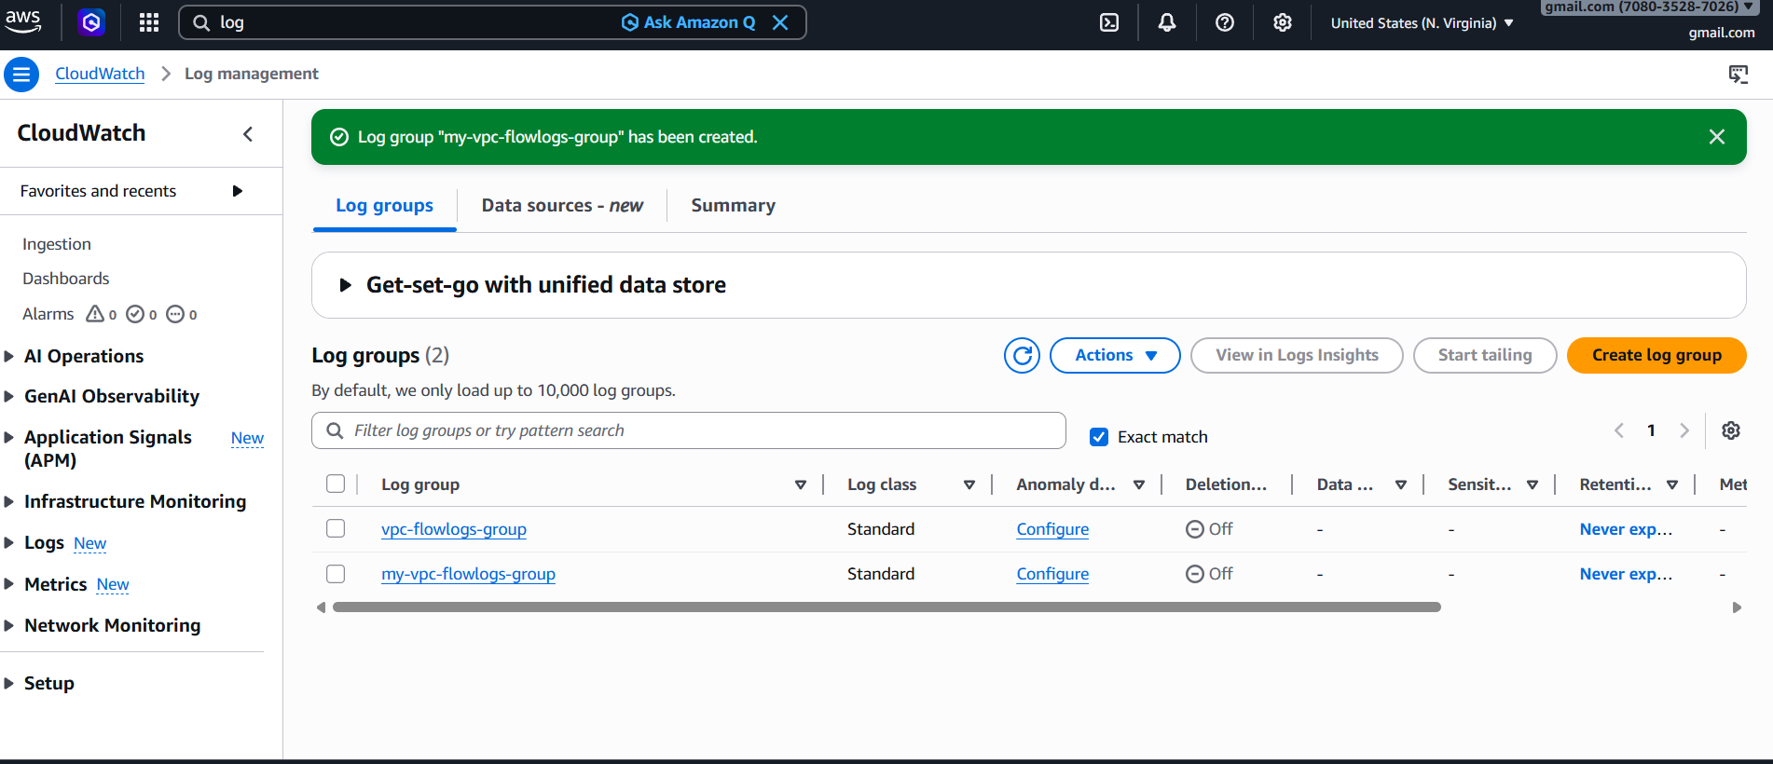

**Result**: CloudWatch Log Group created successfully

PART C: Create IAM Role

Step 1: Search for IAM

Step 2: Click Roles → Create role

Step 3: Select AWS Service

Step 4: Select VPC

Step 5: Click Next

Step 6: Attach policy "CloudWatchLogsFullAccess"

Step 7: Click Next

Step 8: Enter Role name: VPCFlowLogsRole

Step 9: Click Create role

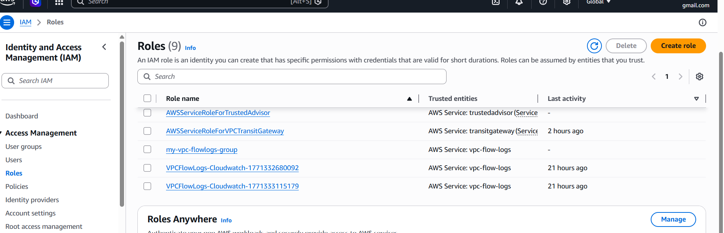

**Result**: IAM Role created successfully

**PART D: Create Flow Log for CloudWatch**

Step 1: Open VPC Dashboard

Step 2: Click Your VPCs

Step 3: Select your VPC

Step 4: Click Flow Logs tab

Step 5: Click Create flow log

Step 6: Select Filter: All

Step 7: Select Destination: CloudWatch Logs

Step 8: Select Log Group: my-vpc-flowlogs-group

Step 9: Select IAM Role: VPCFlowLogsRole

Step 10: Click Create flow log

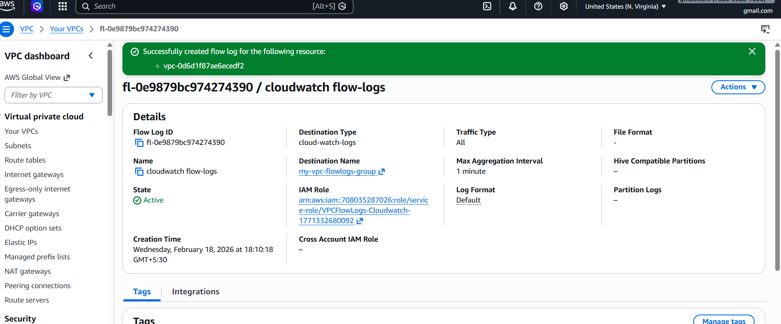

**Result:** Flow Logs sending to CloudWatch

**PART E: Create Flow Log for S3**

Step 1: Click Create flow log again

Step 2: Select Filter: All

Step 3: Select Destination: S3

Step 4: Select bucket: my-vpc-flowlogs-bucket-12345

Step 5: Click Create flow log

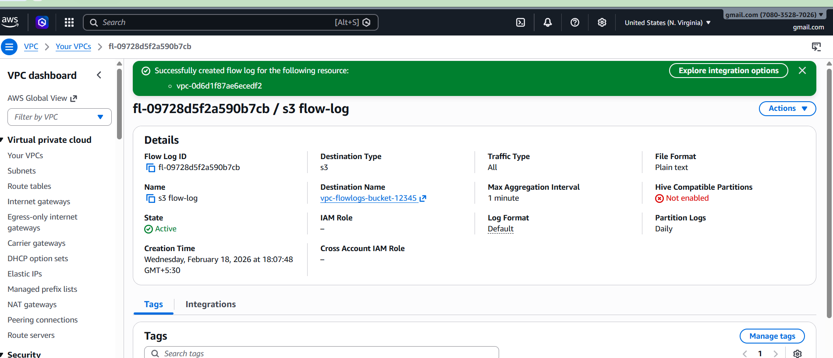

**Result:** Flow Logs sending to S3

**Verification:**

**CloudWatch Verification:**

• Open CloudWatch

• Open Log groups

• Select my-vpc-flowlogs-group

• Verify log streams and entries

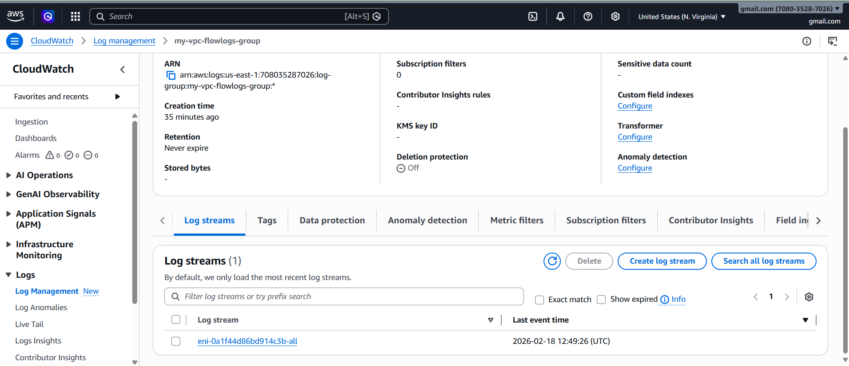

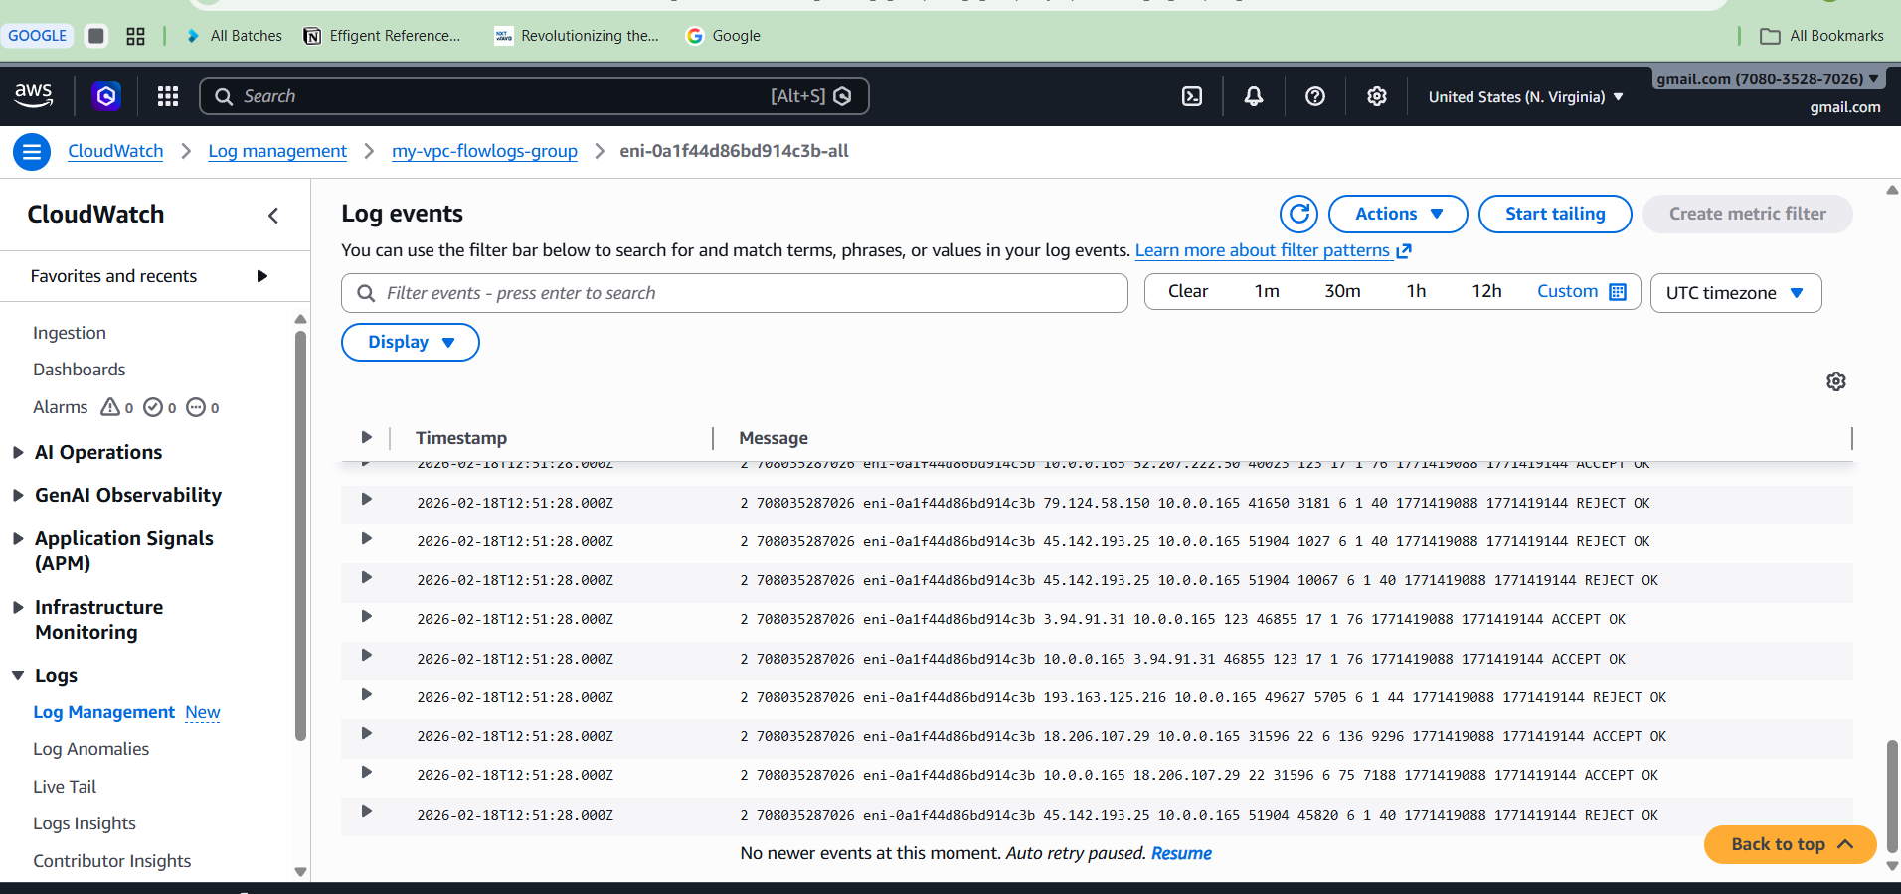

**S3 Verification:**

• Open S3

• Open bucket my-vpc-flowlogs-bucket-12345

• Verify log files

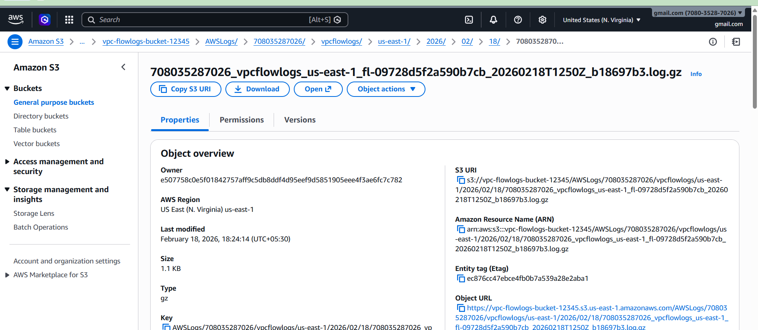

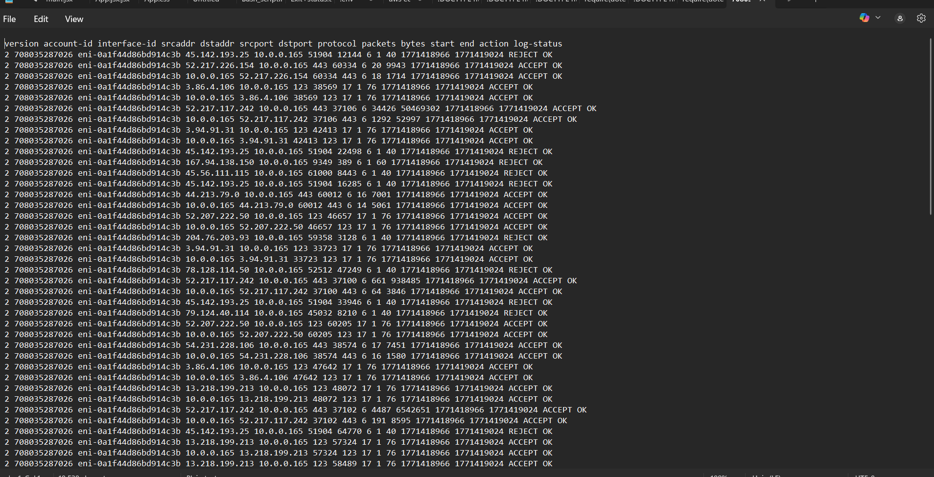

**Conclusion:**

VPC Flow Logs successfully configured and stored in both CloudWatch and S3.